CONFIDENTIAL

Acme Ice Cream LLC
High quality handmade goodness

Business Plan
January 2014

John Doe
312 Blue Valley Street
Wilmington, DE 19801US
888-888-8888
John.Doe@gmail.com
http://www.acmeicecream.com

Table of Contents
Executive Summary 1
Summary 1
Management Team 1
Products and Services 2
Customers 2
Financial Forecast 2
Required Funds 3
Company and Financing 5
Company Overview 5
Management Team 5
Required Funds 6
Exit Strategy 6
Mission Statement 7
Company History 7
Locations and Facilities 7
Products and Services 9
Products and Services 9
Competitors 9
Sourcing and Fulfillment 10
Technology 10
Intellectual Property 11
Future Products and Services 11
Customers 13
Market Overview 13
Market Needs 13
Market Trends 14
Market Growth 14
Industry Analysis 15
Key Customers 16
Marketing and Sales 17
Overview 17
Positioning 17
Pricing 17
Promotion 18
Distribution 19
Strategy and Implementation 20
Milestones 20
SWOT Analysis 20
Competitive Edge 21
Strategic Alliances 21
Financial Plan 23
Sales Forecast 23
Personnel Plan 24
Budget 25
Cash Flow Assumptions 26
Loans and Investments 27
Starting Balances 27
Historical Financials 28
Key Metrics for Success 28
Financial Statements 29
Profit and Loss Statement Table 29
Balance Sheet Table 31
Cash Flow Statement Table 32
Financial Ratio Table 34
Appendix 37
Sales Forecast 37
Personnel Plan 42
Budget 44
Loans and Investments 50
Profit and Loss Statement 51
Balance Sheet 57
Cash Flow Statement 62
Glossary 68

Executive Summary

Summary
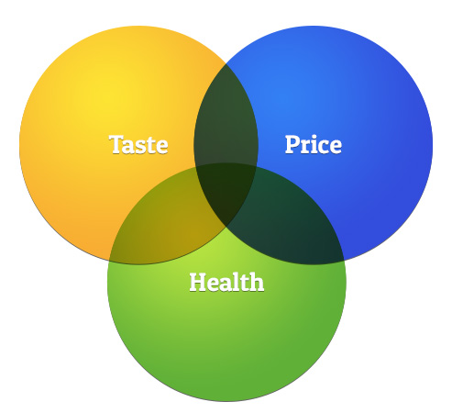Acme Ice Cream LLC will offer customers in downtown Wilmington a variety of artisan ice creams, frozen yogurt, and drinks. It is an ice cream store designed to stand out as a healthy lifestyle brand with homemade ice cream using locally sourced ingredients, as well as establishing itself as a comfortable environment for people to relax and enjoy. It plans on creating a homey yet technologically-advanced space with the option of using tablet menus at each table to place orders as well as boasting exceptional customer service.
By creating a one-of-a-kind ice cream store, Acme Ice Cream plans to attract the young professional working in the downtown Wilmington area, as well as teenagers and local families with children.
The purpose of this business plan is to raise $200,000 for the development and expansion of a ice cream store (Acme Ice Cream LLC) in downtown Wilmington, DE. The investment will help the company build out its flagship retail location in downtown Wilmington and provide working capital for the first six months of operations.

Management Team

Acme Ice Cream will be owned by two partners, John Doe and Jane Doe. John has a strong background in marketing and the food industry, with previous experience working at Ben & Jerry's and Proctor and Gamble. Jane Doe brings 10 years of managerial expertise after working in multinational hospitality firms, including Marriott International and Starwood's Group Ltd.
In addition to the two owners, Acme Ice Cream will have an advisory board consisting of two members, Peter Smith and Jessica Peters. Peter Smith has over 30 years of experience in the fast food industry and Jessica Peters is the current CFO of West Technologies Limited with more than 20 years experience in finance and accounting.

Products and Services

The company will sell three products: specialty ice cream, frozen yogurt, and a beverage selection dependent on the season. The first two products, ice cream and frozen yogurt, will be the signature product sold by the cup or cone. There will be regular flavors available, with plans to add in limited seasonal flavors. All the products will be hand-made with locally sourced, organic ingredients and will be promoted as a healthy lifestyle brand.

Customers

Acme Ice Cream will target three customer segments: young professionals, families, and teenagers. The location of the store in downtown area of Wilmington, DE is a prime spot for both working professionals looking for a treat, as well as local residents. The company will utilize storefront promotions and Internet marketing to get the word out, with an emphasis on social media marketing to encourage positive word of mouth.

Financial Forecast

The company expects to generate at least $700,000 in annual sales by the end of the first year of operations with a gross margin of 23%. The company will incur higher expenses for startup costs for the first year but the company expects to turn a profit within the second year of operation with steadily increasing sales and growing customer base.
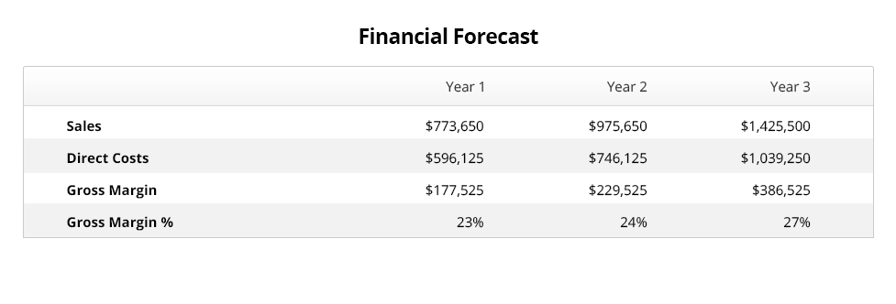

Required Funds

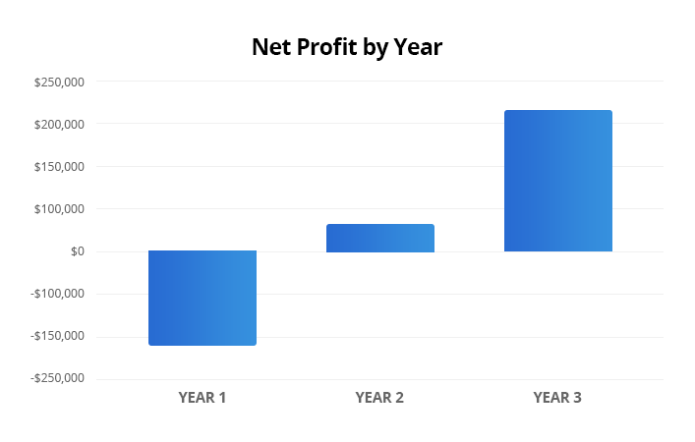

The company is seeking to raise $200,000 from an investor. This business plan assumes the investor will receive 20% equity in the company, with John Doe retaining 80% ownership. The financing will be used to secure the lease on the company's flagship store and working capital for the first six months of operations. The company has an aggressive expansion plan to acquire significant market share and grow its product offering beyond retail operations.
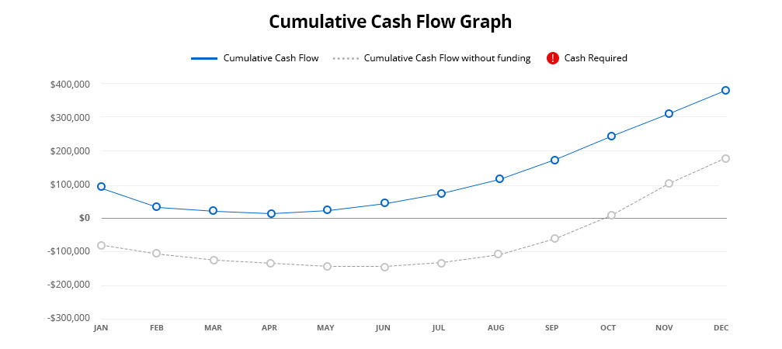

Company and Financing

Company Overview
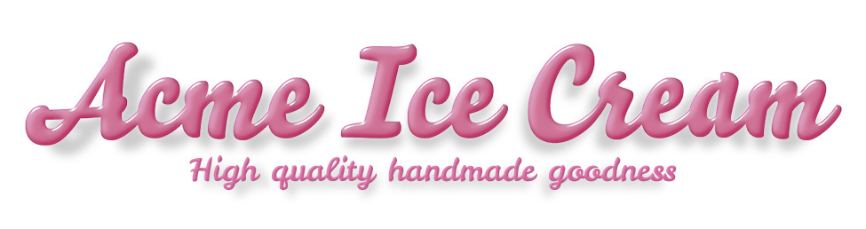
Acme Ice Cream LLC is a single member limited liability company incorporated in the state of Delaware. It was incorporated Jan 1, 2013 and is currently located at 312 Blue Valley Street, Wilmington, DE. The planned store location is situated at 10 Main Street, Wilmington, Delaware. The company was originally conceived in March 2012 when founder and CEO, John Doe, came up with the idea that a locally sourced, artisanal ice cream shop was sorely lacking in downtown Wilmington, DE.

Management Team

John Doe, Founder and CEO
Prior to founding Acme Ice Cream LLC, John Doe was Regional Manager of Ben & Jerry's Northeast Region, where he was responsible for managing all aspects of operations for over 50 retail locations. Prior to Ben & Jerry's, John Doe held multiple positions at Proctor and Gamble, spanning supply chain management and sourcing/fulfillment. John Doe holds a B.S. in Marketing from George Washington University.

Jane Doe, COO
Jane Doe has held managerial positions at several multinational hospitality firms, including Marriott International and Starwood's Group Ltd. Jane Doe also has significant experience in marketing, sales, operations and customer service. She holds a B.S. in Accounting from George Washington University.

Peter Smith, CFO
Peter has over 30 years of experience in the fast food industry. He was the CEO of Restaurant EZ Solutions, a holding company with over 100 McDonalds franchise locations under management. He is the Chairman of the Delaware Chamber of Commerce and two-time winner of Wilmington, DE Entrepreneur of the Year. He holds a B.S. in Physics from the University of Maryland and a MBA from Florida State University.

Jessica Peters, CFA
Jessica Peters is the CFO of West Technologies Limited, an accounting and technology firm located in Wilmington, DE. She brings a wealth of knowledge in accounting, finance, and business operations. Jessica holds a B.A. in Accounting from the University of Pittsburgh and is a licensed Accountant.

Required Funds

John Doe is seeking to raise $200,000 from an investor. The investor will receive a 20% equity share in Acme Ice Cream LLC, with John Doe retaining 80% ownership. The investor shall not have any active role in the day-to-day operations of the company, or have the power to bind the company with any contract, agreement, promise or undertaking. Further details of the proposal will be provided in the company’s operating agreement.
The investment capital will be used for the following:
- Startup expense of retail store
- Six month operating expense
- Marketing campaign to promote store launch
The investment will be required to meet the company’s first milestone, which is reaching positive cash flow, by month 6 of operations. John Doe will also invest $50,000 during this investment round.
The company is projected to generate $1.7 million in revenue by end of year 3, with a profit margin of 35%. The company valuation by year 3 of operations, using comparable businesses in the local region, is approximately $1.5M.

Exit Strategy

Distributions made to members of the company will be made annually, within 75 days of the end of the year. Each member will receive their share on any profits over and above the following two months’ operating expenses (Jan and Feb). This amount will be required to maintain operations and generate revenues necessary to keep the company solvent. In the event of a loss, no profits will be paid.
Assuming the venture is able to meet its financial projections, Mr. Doe intends to further expand to more retail locations across the downtown Wilmington area. The eventual exit strategy would entail packaging the entire chain of ice cream stores and selling them to a third party. There are several holding companies in the region that have a history of acquiring success franchises with revenue exceeding $3.5M. Based on our analysis, similarly typed businesses in this geographic area could secure a valuation up to 3X EBITA.

Mission Statement

To provide the region’s most innovative ice creamery that emphasizes customer service, social responsibility, and extremely high quality product as ingredients to its success.

Company History

John Doe first conceptualized Acme Ice Cream LLC in March 2012 when he realized there were no local ice cream shops in downtown Wilmington that sourced from local vendors and provided a fun and friendly atmosphere. Using his personal residence's kitchen as the first test kitchen, John Doe started to tinker with recipes for the company's line of hand-made ice cream. Within a couple of months Mr. Doe was able to complete his line of artisanal ice cream, including the signature flavor: Madagascar dark chocolate. He shortly thereafter incorporated as Acme Ice Cream LLC and recruited his wife, Jane Doe, to help him with the business.

Locations and Facilities

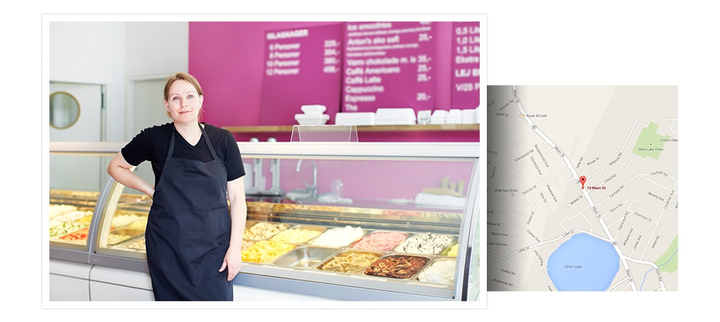
The company plans to rent a retail storefront in downtown Wilmington, DE located on 10 Main Street. The facility is 1,200 square feet and is zoned for commercial use. It possesses the following:
- Restaurant-grade refrigerator and deep-freeze refrigerator
- Modern lighting and electrical system; fire suppression system
- Modern alarm system
- 2 bathrooms
- Small office
- Loading zone with 3 parking spaces
- Remodeled in Feb 2012, featuring hardwood floors and painted walls
The company is able to secure the location with extremely favorable terms with a three year lease with no price increases guaranteed for the duration of the lease.

Products and Services

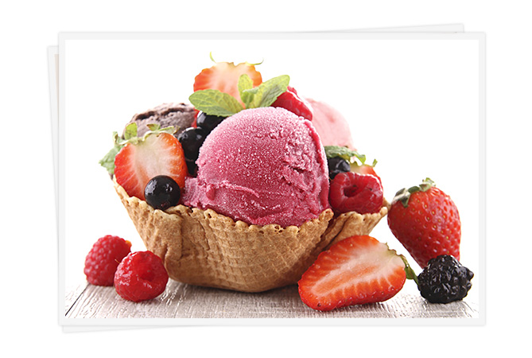Products and Services

The company plans to sell two food products: ice cream, and for health conscious consumers, frozen yogurt. All products are hand-made and feature locally sourced ingredients, including organic whole milk cream and eggs from Hudson Family Farms. Hudson Family Farms is a local farm that provides top-shelf dairy products to high-end restaurants all across the Eastern United States.
Specialty ingredients, such as Madagascar dark chocolate, are all certified organic as well. All products are available by the scoop and can be purchased in a cup or cone. There are also plans to produce seasonal products, such as pumpkin flavored ice cream during autumn.
Drinks would be an additional product offered depending on the season. Hot drinks will be offered during the winter season, while during the summer ice cream shakes will be part of the treats offered.

Competitors

The company's primary competitor is Ben & Jerry's, who has four franchises and one company-owned store in the downtown Wilmington, DE area. They are the only competitor that provides premium-priced ice cream in the area, and so dominate the market. The franchise model generates significantly less profit, which will provide us with an advantage, as we will be able to beat them on price. Their primary means of marketing are coupons distributed in the weekly locals paper and reliance on their brand name recognition, which is bolstered by national-level marketing campaigns.
We believe there is customer demand for hand-made, artisanal ice cream as that is a prominent trend as consumers shy away from mass manufactured food products.
Indirect competitors include grocery stores, convenient stores, and casual-style restaurants. However, there is no direct competitor making hand-made ice cream in interesting and exotic flavors.

Sourcing and Fulfillment

The company plans to source majority of its raw ingredients with local suppliers. The overall cost for this sourcing strategy is not higher than sourcing using a low-cost supplier method when looking at ancillary costs. All suppliers critical to the company's operation have been vetted as having been in business for at least five years, have excellent trading history and applicable licenses, and reputable references. The company has negotiated net-30 terms with all suppliers. In terms of capacity, the company’s suppliers have stated their ability to provide adequate materials for the company to quadruple in size without an issue.
All products will be make-to-stock: each day’s supply will be modified based on forecasted demand. Over time the company will be able to forecast with precision the amount quantity to produce on a daily basis.

Technology
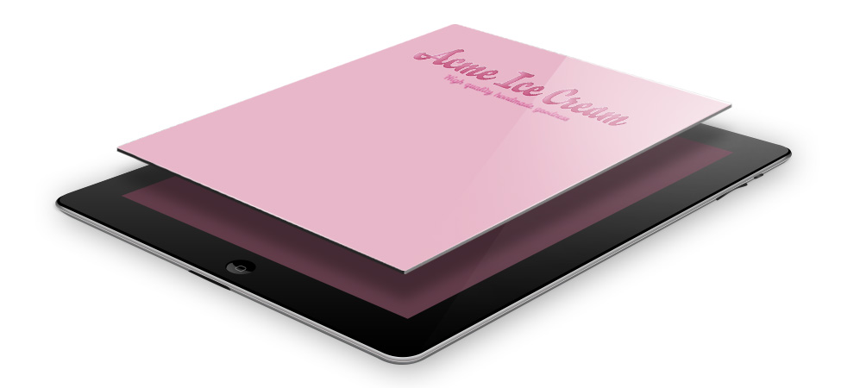
While the ice cream produced is hand-made, the company will utilize several technologies to improve operational efficiency.
Customer relationship management software Ice cream machines
The company will import several professional-grade ice cream machines from Italy that can also produce frozen yogurt. These machines will enable the company to produce a finer ice cream, at a rate that is 20% faster than traditional ice cream machines.
The company will utilize proprietary customer relationship management software to track each customer that purchases from the store, which will enable the company to re-market to those customers and encourage word of mouth marketing.
Demand analysis software
The company will utilize proprietary demand analysis software, which will forecast how much raw materials and inventory to keep on hand. As more data is collected, the software will improve its accuracy and enable the company to optimize its inventory levels.
Tablet ordering software
The company will utilize an ordering system that will allow customers to place orders via tablet devices at each table. Touch screens are an easy way of intuitively browsing the menu selection and ordering. This will increase the order efficiency as well as have a novelty factor to increase customer satisfaction. Customers will still have the option of ordering at the counter.

Intellectual Property

The company has filed for a patent related to its demand analysis software, which John Doe developed and applied for prior to founding the company.
Inventor: John Doe
Applicant: John Doe
Application Number: US19930109867
Title: Demand analysis of dynamic inventory levels
Abstract: A technique for analyzing optimal inventory levels specifically for restaurant and food service industry, which utilizes regression analysis on historical inventory consumption levels, seasonality, and other environmental factors.

Future Products and Services

The company plans to use ice cream and frozen yogurt as a platform in which to launch derivative products, based on the most popular flavors. Two-fold strategy includes:
Testing new flavors that are in season
For example, sriracha hot sauce is a hugely popular hot-sauce condiment that the company could experiment with, at a much quicker pace then the national players. Once a flavor has proven itself with customers, the company can quickly develop derivative products off that flavor platform.
Derivative products
There are a variety of derivate products the company will pursue, including:
- Sundaes
- Floats
- Cones
- Cups
- Various toppings

Customers

Market Overview
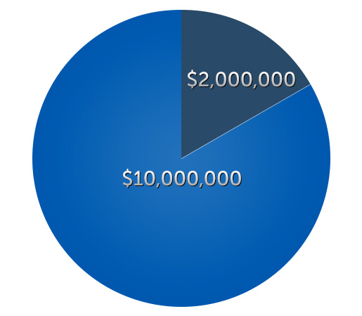The total market for Acme Ice Cream LLC includes all consumers in the Wilmington, DE area that enjoy premium ice cream at least once a month. The addressable market that the company is going to target are consumers that prefer organic and locally grown products and are willing to pay a premium to support brands that promote these values.
Conservatively, the total market is estimated to be $10 million, with the addressable market to be $2 million. The total market size was calculated by taking estimated annual revenue for one Ben & Jerry’s franchise ($2 million) and multiplying by five (taking into account total number of Ben & Jerry locations). We estimate taking 20% of the total market based on a survey conducted in Aug 2013 asking Wilmington consumers if they would be willing to pay a premium for organic and artisanal food products, in which 20% of survey respondents answered yes.

Market Needs

The company's product line provides an ice cream experience not found in any other store in Wilmington - local and organic, hand-made and seasonal premium ice cream. While ice cream shops like this exist in larger cities such as Philadelphia, New York and Washington DC, they are sorely missing in Wilmington. The collision of organic and premium is two hot trends that the company will capitalize on.
Trend towards organic
The national trend towards organic alternatives is also one that is well documented. Total U.S. organic sales, including food and non-food products, were $28.682 billion in 2010, up 9.7 percent from 2009. (Source: Compass Natural)
Trend towards premium
Premium ice cream, which tends to have lower amount of aeration and higher fat content than regular ice cream, is the most popular product with consumers according to a recent survey of U.S. ice cream manufacturers. In the survey, 79.3 percent cited premium ice cream as the most popular product made. (Source: IDFA ice cream company survey, 2012)

Market Trends

The trend to go organic and avoid “big-agriculture” is a national phenomenon as seen with the meteoric success of national chains such a Chipotles, which emphasizes the quality of their ingredients. Recent studies have shown that the fastest growing segment in the casual restaurant industry is companies that emphasize healthy food options.
At the local level, the downtown Wilmington, DE area has seen significant gentrification as the number of young professionals and families that have moved in have grown exponentially over the past 10 years. This demographic, defined as Urban Achievers (U2 31) on the PRIZM segmentation system, have large disposable incomes ($55,000 and above), are well educated (70% with Bachelors Degree or higher), and are interested in maintaining healthy lifestyles (more likely to drive a Prius then a Hummer).
At the customer and product level, consumers of premium ice cream are not price sensitive and have been proven to readily accept the higher price point associated with premium ice cream. We do not expect this trend to end.

Market Growth

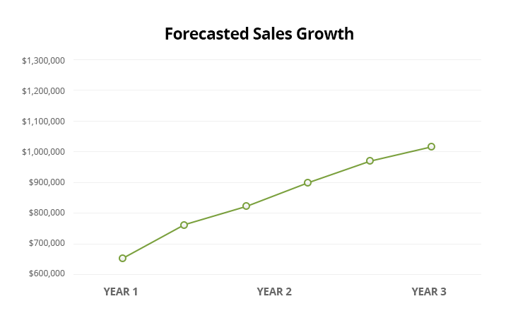
There are currently five ice cream shops in downtown Wilmington. Three years ago there were only two. With each ice cream location generating approximately $2 million in annual sales, we can forecast the market growth over the past years to be 300%.
Furthermore, using data collected from Ben & Jerry’s franchise prospectus, we can also see same store sales for the Wilmington area growing over the past five years.
Using data from the Department of Labor, there has also been a net increase in the number of jobs in the area. This is also encouraging and provides further validation that the market for premium ice cream is growing.

Industry Analysis

The ice cream industry is a $10 Billion industry in the United States.
NAICS classification: 7334455: Ice cream, soft drink and soda fountain stands.
Threat of new entrants:
The threat of new entrants are relatively low given the upfront costs associated with a retail restaurant operation, coupled with the R&D required to develop a line of ice cream flavors. Furthermore, prime real estate location for such a operation are limited, which in itself is a significant barrier to entry.
Bargaining power of suppliers:
There are adequate suppliers of the company’s required raw products that over time, we expect to improve margins as volume increases. Further, we have developed strong relationships with our suppliers through long-standing business partnerships forged by the founder and CEO, as well as through the company’s advisory board.
Bargaining power of buyers:
There is a relatively large base of ice cream consumers that the company should not witness any downward pricing pressure from buyers. In addition, premium ice cream has traditionally commanded a high price point that consumers are accustomed to.
Availability of substitutes
While there is other ice cream shops around Wilmington, none currently offer the unique product features we are planning on offering. We hope that this unique selling proposition will be a strong enough incentive for us to retain customer loyalty.
Competitive rivalry
We anticipate that competitors will eventually mimic our product offering and branding, which will increase competition. In addition, there is a limit to the growth in the overall market as Wilmington’s gentrification is slowing down. However, we hope that by establishing ourselves as the original and first organic, hand-made ice cream shop, that we will carve out defensive market share.

Key Customers

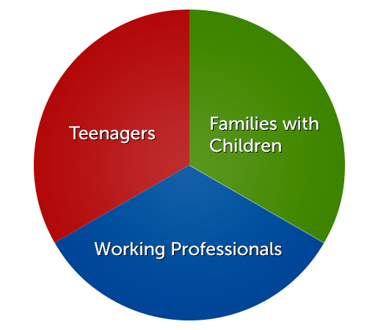
Acme Ice Cream has three customer segments to which they will target their products.
Families: One key customer segment is families, in particular young parents who want to bring their children to the store. For this segment, the average order value will not only be higher, but the frequency in which they will return will also be higher. By promoting an organic alternative, the company hopes to secure loyal parents and their children.
Teenagers: Historically teenagers comprise a large customer segment for ice cream shops. Conveniently located in a downtown location with a high school within a 10-minute walk, Acme Ice Cream will be in a prime spot for teenagers who want to grab a snack or to hang out after school.
Working professionals: The high density of companies in downtown Wilmington area allows Acme Ice Cream to be easily accessible to working professionals who are looking for a treat on their lunch break or after work. Acme Ice Cream will also be open to holding company gathering or events.

Marketing and Sales

Overview

Acme Ice Cream LLC will market its line of organic, artisanal ice cream and frozen yogurt through social media and word of mouth marketing. It will price its products comparable to its nearby competitors, while providing smaller portions in order to maintain profitability. It may seek to distribute its products through wholesale channels if brand recognition and consumer demand warrants such expansion.

Positioning

Acme Ice Cream will offer a differentiated product offering, promoting itself as the first and only organic, hand-made ice cream shop. By producing out of the ordinary ice cream flavors such as Madagascar chocolate, we aim to target the growing population of savvy consumers that have moved into the downtown Wilmington, DE area.
As a purveyor of premium ice cream, we do not expect a higher price point to be an issue. Furthermore, we will bolster the company’s brand as a lifestyle choice – helping consumers to identify with our positioning as an organic, healthy, modern and sophisticated offering.

Pricing

Acme Ice Cream LLC has determined that its target consumer is only moderately price sensitive and therefore, would be willing to pay a premium for quality. Therefore, the company's pricing strategy is to offer a premium product at a premium price-point.
Compared to other rival stores in Wilmington, the company's price for a scoop of ice cream will be competitive. If looking at comparable pricing from a unit price perspective, however, the company will be approximately 10% higher. In other words, the company's scoop of ice cream will be smaller than its competitors but come in at the same price point. This is to help recoup the higher costs associated with higher raw ingredient costs.
There will be two pricing variations:
- Retail: full, retail price of products
- Discounted: from time to time the company will offer discounts in order to boost sales, which may include up to 50% off the retail price. Running daily deal offers (i.e.; Groupon) and “Buy 1, Get 1 Free” offers will include the maximum 50% off retail.

Promotion

Internet marketing
The objective is to obtain enough new customers to generate positive word of mouth through social media, with emphasis on the company’s Facebook, Twitter, Pinterest, Youtube and Tumbler profiles. The company believes that social media will be critical to the success of its customer acquisition strategy, as each incremental gain in social media will increase overall profitability. Development of a company website will compliment the overall Internet marketing strategy.
The company will also utilize paid Internet marketing channels, including Google Adwords, Groupon and LivingSocial. As these campaigns can be very expensive, the company will take a cautious approach towards these campaigns.
Lastly, the company will place heavy emphasis on mobile marketing through the use of QR codes to administer coupons, social media check-ins to claim discounts, and free wifi to encourage more mobile device usage.
Traditional media
The company will initiate several local marketing campaigns to get the word out, including one big launch campaign on local radio station 99.5 FM, where we will purchase several slots throughout launch week offering buy 1 scoop get 1 scoop free campaign. Each month we will also launch different campaigns, such as Kids under 12 get a free scoop day.
Print advertising such as flyers will also be used to be distributed to the local school and businesses in the area to promote the store's grand opening and special events.
In addition, the company will entice walk-in business through the strategic placement of an Ice Cream Mascot shaped as a huge ice cream cone. This will entice children as well as tourists who would like to get their picture taken with the lively and comical mascot.

Distribution

The current focus is on delivering an exceptionally well in-store experience for the consumer, which serves as the only distribution point. Future expansion includes selective distribution through restaurants in the area in order to maintain high quality, as all products are hand-made. In addition, the company has explored distributing its product through its suppliers, with Hudson Valley Farms providing a verbal agreement to run a test campaign. By maintaining limited quantities available for distribution, we can ensure the brand retains its exclusivity and quality.

Strategy and Implementation

Milestones

Opening the first store location
Completion Date: Year 0, Month 1
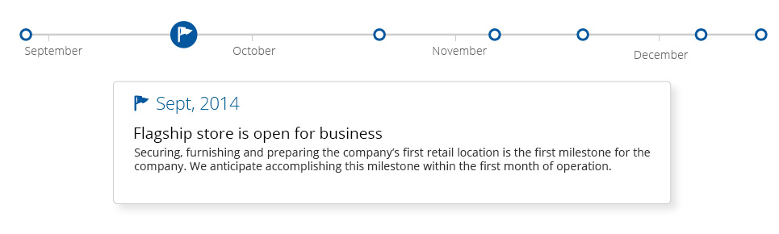
Securing, furnishing and preparing the company’s first retail location is the first milestone for the company. We anticipate accomplishing this milestone within the first month of operation.

Achieving positive cash flow
Completion Date: Year 1, Month 6
Within month six of operations the company expects to attain positive cash flow from operations.

Achieving break even
Completion Date: Year 1, Month 12
Within year two of operations, the company expects to reach break even.

SWOT Analysis

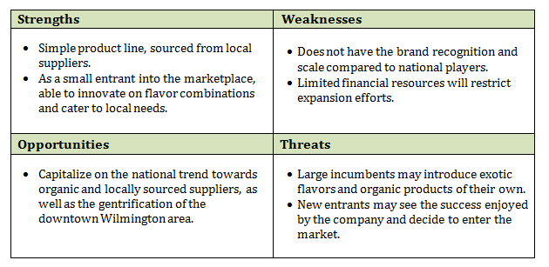

Competitive Edge
The company plans to compete on several vectors:
Differentiation:
We will be the only player in town providing stand-out flavors and organic ingredients. We will also be the only store with touch screen menus and ordering system. More than just an ice cream shop, Acme Ice Cream will represent a life style choice that resonates with the new urbanites inhabiting Wilmington.
Innovation:
By using a platform strategy, we will quickly produce derivative products based off the most popular flavors. This will allow us to capitalize on new flavor trends before our competitors and monetize more effectively.
Operational efficiency:
By utilizing patent-pending technology we will be able to optimize our supply chain, achieving parity with the national and regional players while maintaining the advantages of a small and nimble operation.

Strategic Alliances

The company has extremely strong relationships with local suppliers, including Hudson Valley Farms and Picante and Sons. The founder and CEO, John Doe, has worked with these suppliers for over a decade. These alliances provide the company with preferential pricing and assurances of product quality and consistency.
The company’s advisory board is made up of local business leaders that have significant influence, both with local businesses (including competitors), as well as the local and state government.

Financial Plan

Sales Forecast

Sales Forecast Table
 | 2014 | 2015 | 2016
Unit Sales
Ice Cream | 95,000 | 125,000 | 191,000
Frozen Yogurt | 13,350 | 13,350 | 14,800
Beverages | 12,000 | 12,000 | 12,000
Price Per Unit
Ice Cream | $6 | $6 | $6
Frozen Yogurt | $9 | $9 | $10
Beverages | $3 | $3 | $3
Sales
Ice Cream | $617,500 | $812,500 | $1,241,500
Frozen Yogurt | $120,150 | $127,150 | $148,000
Beverages | $36,000 | $36,000 | $36,000
Total Sales | $773,650 | $975,650 | $1,425,500
Direct Cost Per Unit
Ice Cream | $5 | $5 | $4
Frozen Yogurt | $7 | $7 | $7
Beverages | $1 | $1 | $1
Direct Cost
Ice Cream | $475,000 | $625,000 | $764,000
Frozen Yogurt | $100,125 | $100,125 | $111,000
Beverages | $21,000 | $21,000 | $21,000
Total Direct Cost | $596,125 | $746,125 | $896,000
Gross Profit | $177,525 | $229,525 | $529,500
Gross Profit % | 23% | 24% | 37%

Sales by Month
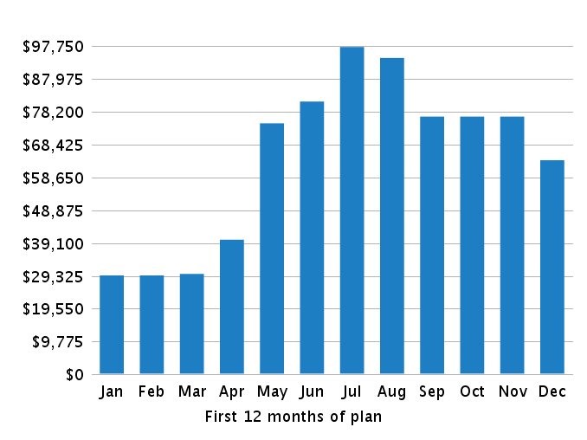

Personnel Plan

Personnel Table
 | 2014 | 2015 | 2016
CEO | $40,000 | $40,000 | $40,000
Full-time Employee 1 | $30,000 | $31,500 | $33,000
Full-time Employee 2 | $30,000 | $31,500 | $33,000
Full-time Employee 3 | $0 | $35,000 | $36,750
Total | $100,000 | $138,000 | $142,750

Budget

Budget Table
 | 2014 | 2015 | 2016
Expenses
Salary | $100,000 | $138,000 | $142,750
Employee Related Expenses | $20,000 | $27,600 | $28,550
Lease Payments | $60,000 | $60,000 | $60,000
Supplies | $2,400 | $2,400 | $2,400
Utilities | $5,400 | $5,400 | $5,400
Advertising | $11,300 | $11,300 | $24,000
Local Radio Station Marketing Campaign | $35,000 | $0 | $0
Professional Fees | $3,000 | $0 | $0
Improvements & Construction | $60,000 | $0 | $0
Customer Relationship Management Software | $3,000 | $0 | $0
Demand Analysis Software | $2,000 | $0 | $0
Tablet Ordering System | $2,500 | $0 | $0
Insurance | $4,200 | $4,200 | $4,200
Total Expenses | $308,800 | $248,900 | $267,300
Long-term Assets
Total Long-term Assets | $0 | $0 | $0
Other Current Assets
Total Other Current Assets | $0 | $0 | $0
Dividends and Distributions
Total Dividends and Distributions | $0 | $0 | $0

Expenses by Month
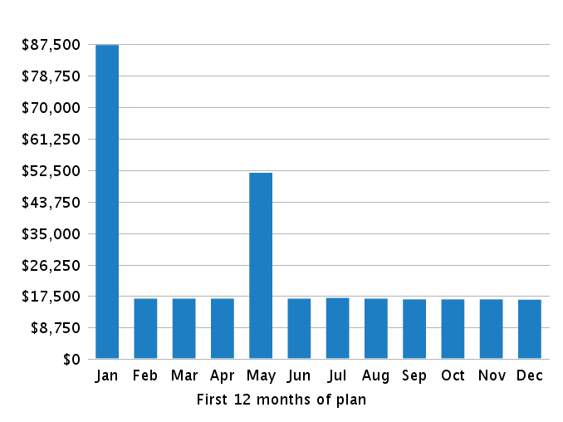

Cash Flow Assumptions

Cash Flow Assumptions Table
Cash Inflow
% of Sales on Credit | 40%
 | 30 days
Cash Outflow
% of Purchases on Credit | 50 %
Avg Payment Period (Days) | 60 days
Inventory
Months to Keep on Hand | 1
Minimum Inventory Purchase | 5000

Loans and Investments

Loans and Investments Table
 | 2014 | 2015 | 2016
Investment (John Doe) | $50,000 | $0 | $0
Investment (Outside Investor) | $200,000 | $0 | $0
Total Amount Received | $250,000 | $0 | $0

Starting Balances
Sales
Sales Last Month | $0
Sales 2 Months Ago | $0
Sales 3 Months Ago | $0
Sales 4 Months Ago | $0
Sales 5 Months Ago | $0
Sales 6 Months Ago | $0
Assets
Cash | $0
Accounts Receivable | $0
Inventory | $0
Other Current Assets | $0
Long-Term Assets | $0
Accumulated Depreciation | $0
Liabilities
Accounts Payable | $0
Sales Taxes Payable | $0
Capital
Paid-in Capital | $0
Retained Earnings | $0

Historical Financials

Key Metrics for Success

Financial Statements

Profit and Loss Statement Table
 | 2014 | 2015 | 2016
Revenue | $773,650 | $975,650 | $1,425,500
Direct Cost | $596,125 | $746,125 | $896,000
Gross Profit | $177,525 | $229,525 | $529,500
Gross Profit % | 23% | 24% | 37%
Operating Expenses
Salary | $100,000 | $138,000 | $142,750
Employee Related Expenses | $20,000 | $27,600 | $28,550
Rent Expense | $60,000 | $60,000 | $60,000
Office Supplies | $2,400 | $2,400 | $2,400
Utilities | $5,400 | $5,400 | $5,400
Advertising and Promotion | $46,300 | $11,300 | $24,000
Professional Fees | $3,000 | $0 | $0
Repairs and Maintenance | $60,000 | $0 | $0
Computer and Internet Expense | $7,500 | $0 | $0
Insurance Expense | $4,200 | $4,200 | $4,200
Expensed Portion of Other Current Assets | $0 | $0 | $0
Depreciation and Amortization | $0 | $0 | $0
Total Operating Expenses | $308,800 | $248,900 | $267,300
Operating Income | $(131,275) | $(19,375) | $262,200
Other Expenses (& Other Income)
Loss (or Gain) on Sale of Asset | $0 | $0 | $0
Interest Expense | $0 | $0 | $0
Total Other Expenses (& Other Income) | $0 | $0 | $0
Income Before Income Tax | $(131,275) | $(19,375) | $262,200
Income Taxes | $0 | $0 | $0
Net Income | $(131,275) | $(19,375) | $262,200
Net Income / Sales | (-17%) | (-2%) | 18%

Gross Margin by Year
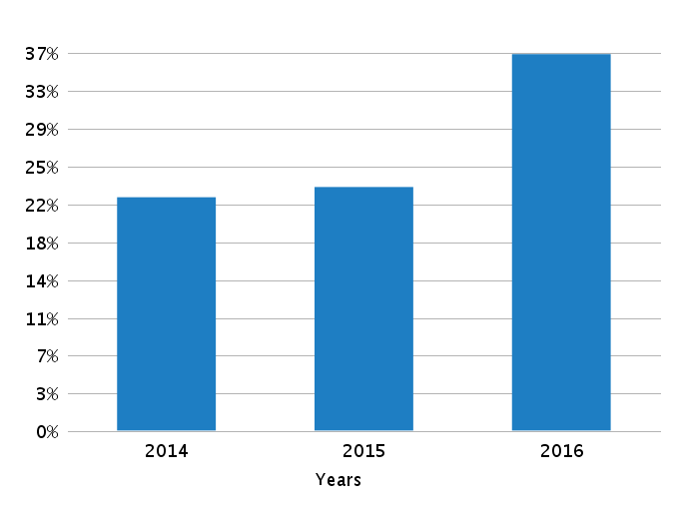

Net Profit (or Loss) by Year
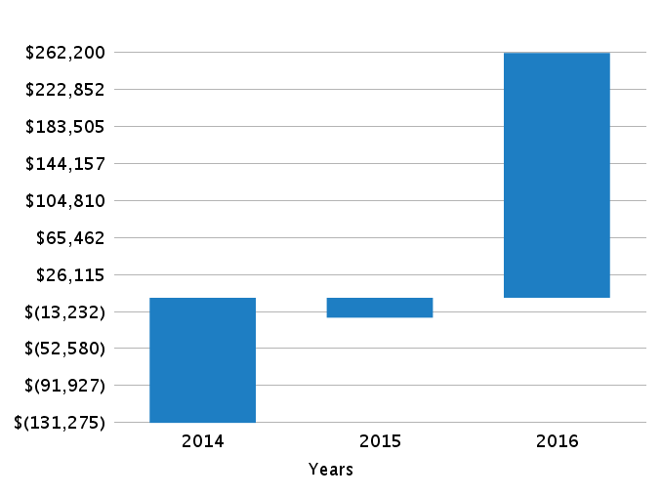

Balance Sheet Table
As of Period's End | Starting Balances | 2014 | 2015 | 2016
Cash | $0 | $101,375 | $81,625 | $317,350
Accounts Receivable | $0 | $25,600 | $28,600 | $44,200
Inventory | $0 | $32,750 | $32,500 | $69,250
Other Current Assets | $0 | $0 | $0 | $0
Total Current Assets | $0 | $159,725 | $142,725 | $430,800
Long-Term Assets | $0 | $0 | $0 | $0
Accumulated Depreciation | $0 | $0 | $0 | $0
Total Long Term Assets | $0 | $0 | $0 | $0
TOTAL ASSETS | $0 | $159,725 | $142,725 | $430,800
Accounts Payable | $0 | $41,000 | $43,375 | $69,250
Sales Taxes Payable | $0 | $0 | $0 | $0
Short-Term Debt | $0 | $0 | $0 | $0
Total Current Liabilities | $0 | $41,000 | $43,375 | $69,250
Long-Term Debt | $0 | $0 | $0 | $0
TOTAL LIABILITIES | $0 | $41,000 | $43,375 | $69,250
Paid-in Capital | $0 | $250,000 | $250,000 | $250,000
Retained Earnings | $0 | $0 | $(131,275) | $(150,650)
Profit and Loss - Current Period | $0 | $(131,275) | $(19,375) | $262,200
TOTAL OWNER'S EQUITY | $0 | $118,725 | $99,350 | $361,550
TOTAL LIABILITIES & EQUITY | $0 | $159,725 | $142,725 | $430,800

Cash Flow Statement Table
 | 2014 | 2015 | 2016
OPERATING ACTIVITIES
Net Income | $(131,275) | $(19,375) | $262,200
Depreciation and Amortization | $0 | $0 | $0
Gain or Loss on Disposal of Asset | $0 | $0 | $0
Change in Accounts Receivable | $(25,600) | $(3,000) | $(15,600)
Change in Inventory | $(32,750) | $250 | $(36,750)
Change in Accounts Payable | $41,000 | $2,375 | $25,875
Change in Sales Taxes Payable | $0 | $0 | $0
Change in Other Current Assets | $0 | $0 | $0
Net Cash from Operating Activities | $(148,625) | $(19,750) | $235,725
INVESTING & FINANCING ACTIVITIES
Long-Term Assets Purchased or Sold | $0 | $0 | $0
Investments and Contributions Received | $250,000 | $0 | $0
Change in Short-Term Debt | $0 | $0 | $0
Change in Long-Term Debt | $0 | $0 | $0
Dividends and Distributions | $0 | $0 | $0
Net Cash from Investing & Financing | $250,000 | $0 | $0
Cash at Beginning of Period | $0 | $101,375 | $81,625
Net Change in Cash | $101,375 | $(19,750) | $235,725
Cash at End of Period | $101,375 | $81,625 | $317,350

Cash Flow by Month
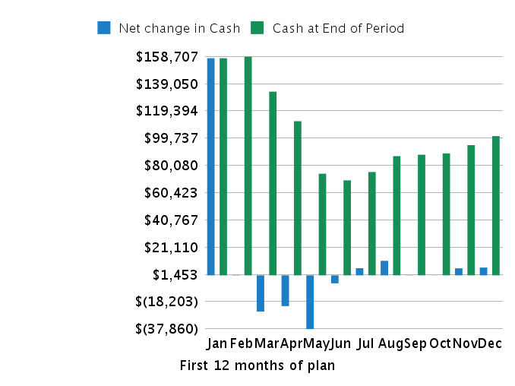

Cash Flow by Year
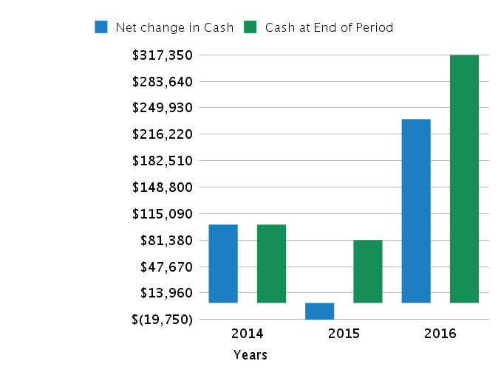

Financial Ratio Table
 | Projected
As of Period's End | 2014 | 2015 | 2016
Liquidity Analysis
Net working capital | $118,725 | $99,350 | $361,550
Current ratio | 390% | 329% | 622%
Quick ratio | 310% | 254% | 522%
Profitability Analysis
Gross profit margin | 23% | 24% | 37%
Operating profit margin | (-17%) | (-2%) | 18%
Net profit margin | (-17%) | (-2%) | 18%
Debt Ratios
Debt to assets | 26% | 30% | 16%
Debt to equity | 35% | 44% | 19%
Investment Measures
ROI | (-82%) | (-14%) | 61%

Appendix

Sales Forecast

Table (With Monthly Detail)
Year1 | 1'14 | 2'14 | 3'14 | 4'14 | 5'14 | 6'14 | 7'14 | 8'14 | 9'14 | 10'14 | 11'14 | 12'15
Units Sales
Ice Cream | 3,000 | 3,000 | 3,000 | 4,500 | 9,000 | 10,000 | 12,500 | 12,000 | 10,000 | 10,000 | 10,000 | 8,000
Frozen Yogurt | 800 | 800 | 850 | 900 | 1,500 | 1,500 | 1,500 | 1,500 | 1,000 | 1,000 | 1,000 | 1,000
Beverages | 1,000 | 1,000 | 1,000 | 1,000 | 1,000 | 1,000 | 1,000 | 1,000 | 1,000 | 1,000 | 1,000 | 1,000
Price Per Unit
Ice Cream | $6 | $6 | $6 | $6 | $6 | $6 | $6 | $6 | $6 | $6 | $6 | $6
Frozen Yogurt | $9 | $9 | $9 | $9 | $9 | $9 | $9 | $9 | $9 | $9 | $9 | $9
Beverages | $3 | $3 | $3 | $3 | $3 | $3 | $3 | $3 | $3 | $3 | $3 | $3
Sales
Ice Cream | $19,500 | $19,500 | $19,500 | $29,250 | $58,500 | $65,000 | $81,250 | $78,000 | $65,000 | $65,000 | $65,000 | $52,000
Frozen Yogurt | $7,200 | $7,200 | $7,650 | $8,100 | $13,500 | $13,500 | $13,500 | $13,500 | $9,000 | $9,000 | $9,000 | $9,000
Beverages | $3,000 | $3,000 | $3,000 | $3,000 | $3,000 | $3,000 | $3,000 | $3,000 | $3,000 | $3,000 | $3,000 | $3,000
Total Sales | $29,700 | $29,700 | $30,150 | $40,350 | $75,000 | $81,500 | $97,750 | $94,500 | $77,000 | $77,000 | $77,000 | $64,000
Direct Cost Per Unit
Ice Cream | $5 | $5 | $5 | $5 | $5 | $5 | $5 | $5 | $5 | $5 | $5 | $5
Frozen Yogurt | $7 | $7 | $7 | $7 | $7 | $7 | $7 | $7 | $7 | $7 | $7 | $7
Beverages | $1 | $1 | $1 | $1 | $1 | $1 | $1 | $1 | $1 | $1 | $1 | $1
Direct Cost
Ice Cream | $15,000 | $15,000 | $15,000 | $22,500 | $45,000 | $50,000 | $62,500 | $60,000 | $50,000 | $50,000 | $50,000 | $40,000
Frozen Yogurt | $6,000 | $6,000 | $6,375 | $6,750 | $11,250 | $11,250 | $11,250 | $11,250 | $7,500 | $7,500 | $7,500 | $7,500
Beverages | $1,750 | $1,750 | $1,750 | $1,750 | $1,750 | $1,750 | $1,750 | $1,750 | $1,750 | $1,750 | $1,750 | $1,750
Total Direct Cost | $22,750 | $22,750 | $23,125 | $31,000 | $58,000 | $63,000 | $75,500 | $73,000 | $59,250 | $59,250 | $59,250 | $49,250
Gross Margin | $6,950 | $6,950 | $7,025 | $9,350 | $17,000 | $18,500 | $22,250 | $21,500 | $17,750 | $17,750 | $17,750 | $14,750
Gross Margin % | 23% | 23% | 23% | 23% | 23% | 23% | 23% | 23% | 23% | 23% | 23% | 23%

Year2 | 1'15 | 2'15 | 3'15 | 4'15 | 5'15 | 6'15 | 7'15 | 8'15 | 9'15 | 10'15 | 11'15 | 12'16
Units Sales
Ice Cream | 5,000 | 5,000 | 5,000 | 7,000 | 12,000 | 15,000 | 16,000 | 18,000 | 12,000 | 11,000 | 10,000 | 9,000
Frozen Yogurt | 800 | 800 | 850 | 900 | 1,500 | 1,500 | 1,500 | 1,500 | 1,000 | 1,000 | 1,000 | 1,000
Beverages | 1,000 | 1,000 | 1,000 | 1,000 | 1,000 | 1,000 | 1,000 | 1,000 | 1,000 | 1,000 | 1,000 | 1,000
Price Per Unit
Ice Cream | $6 | $6 | $6 | $6 | $6 | $6 | $6 | $6 | $6 | $6 | $6 | $6
Frozen Yogurt | $9 | $9 | $9 | $9 | $9 | $9 | $10 | $10 | $10 | $10 | $10 | $10
Beverages | $3 | $3 | $3 | $3 | $3 | $3 | $3 | $3 | $3 | $3 | $3 | $3
Sales
Ice Cream | $32,500 | $32,500 | $32,500 | $45,500 | $78,000 | $97,500 | $104,000 | $117,000 | $78,000 | $71,500 | $65,000 | $58,500
Frozen Yogurt | $7,200 | $7,200 | $7,650 | $8,100 | $13,500 | $13,500 | $15,000 | $15,000 | $10,000 | $10,000 | $10,000 | $10,000
Beverages | $3,000 | $3,000 | $3,000 | $3,000 | $3,000 | $3,000 | $3,000 | $3,000 | $3,000 | $3,000 | $3,000 | $3,000
Total Sales | $42,700 | $42,700 | $43,150 | $56,600 | $94,500 | $114,000 | $122,000 | $135,000 | $91,000 | $84,500 | $78,000 | $71,500
Direct Cost Per Unit
Ice Cream | $5 | $5 | $5 | $5 | $5 | $5 | $5 | $5 | $5 | $5 | $5 | $5
Frozen Yogurt | $7 | $7 | $7 | $7 | $7 | $7 | $7 | $7 | $7 | $7 | $7 | $7
Beverages | $1 | $1 | $1 | $1 | $1 | $1 | $1 | $1 | $1 | $1 | $1 | $1
Direct Cost
Ice Cream | $25,000 | $25,000 | $25,000 | $35,000 | $60,000 | $75,000 | $80,000 | $90,000 | $60,000 | $55,000 | $50,000 | $45,000
Frozen Yogurt | $6,000 | $6,000 | $6,375 | $6,750 | $11,250 | $11,250 | $11,250 | $11,250 | $7,500 | $7,500 | $7,500 | $7,500
Beverages | $1,750 | $1,750 | $1,750 | $1,750 | $1,750 | $1,750 | $1,750 | $1,750 | $1,750 | $1,750 | $1,750 | $1,750
Total Direct Cost | $32,750 | $32,750 | $33,125 | $43,500 | $73,000 | $88,000 | $93,000 | $103,000 | $69,250 | $64,250 | $59,250 | $54,250
Gross Margin | $9,950 | $9,950 | $10,025 | $13,100 | $21,500 | $26,000 | $29,000 | $32,000 | $21,750 | $20,250 | $18,750 | $17,250
Gross Margin % | 23% | 23% | 23% | 23% | 23% | 23% | 24% | 24% | 24% | 24% | 24% | 24%

Year3 | 1'16 | 2'16 | 3'16 | 4'16 | 5'16 | 6'16 | 7'16 | 8'16 | 9'16 | 10'16 | 11'16 | 12'17
Units Sales
Ice Cream | 6,000 | 6,000 | 9,000 | 9,000 | 15,000 | 20,000 | 25,000 | 26,000 | 25,000 | 20,000 | 15,000 | 15,000
Frozen Yogurt | 900 | 900 | 900 | 1,000 | 1,000 | 1,200 | 2,000 | 2,000 | 1,200 | 1,200 | 1,500 | 1,000
Beverages | 1,000 | 1,000 | 1,000 | 1,000 | 1,000 | 1,000 | 1,000 | 1,000 | 1,000 | 1,000 | 1,000 | 1,000
Price Per Unit
Ice Cream | $6 | $6 | $6 | $6 | $6 | $6 | $6 | $6 | $6 | $6 | $6 | $6
Frozen Yogurt | $10 | $10 | $10 | $10 | $10 | $10 | $10 | $10 | $10 | $10 | $10 | $10
Beverages | $3 | $3 | $3 | $3 | $3 | $3 | $3 | $3 | $3 | $3 | $3 | $3
Sales
Ice Cream | $39,000 | $39,000 | $58,500 | $58,500 | $97,500 | $130,000 | $162,500 | $169,000 | $162,500 | $130,000 | $97,500 | $97,500
Frozen Yogurt | $9,000 | $9,000 | $9,000 | $10,000 | $10,000 | $12,000 | $20,000 | $20,000 | $12,000 | $12,000 | $15,000 | $10,000
Beverages | $3,000 | $3,000 | $3,000 | $3,000 | $3,000 | $3,000 | $3,000 | $3,000 | $3,000 | $3,000 | $3,000 | $3,000
Total Sales | $51,000 | $51,000 | $70,500 | $71,500 | $110,500 | $145,000 | $185,500 | $192,000 | $177,500 | $145,000 | $115,500 | $110,500
Direct Cost Per Unit
Ice Cream | $4 | $4 | $4 | $4 | $4 | $4 | $4 | $4 | $4 | $4 | $4 | $4
Frozen Yogurt | $7 | $7 | $7 | $7 | $7 | $7 | $7 | $7 | $7 | $7 | $7 | $7
Beverages | $1 | $1 | $1 | $1 | $1 | $1 | $1 | $1 | $1 | $1 | $1 | $1
Direct Cost
Ice Cream | $24,000 | $24,000 | $36,000 | $36,000 | $60,000 | $80,000 | $100,000 | $104,000 | $100,000 | $80,000 | $60,000 | $60,000
Frozen Yogurt | $6,750 | $6,750 | $6,750 | $7,500 | $7,500 | $9,000 | $15,000 | $15,000 | $9,000 | $9,000 | $11,250 | $7,500
Beverages | $1,750 | $1,750 | $1,750 | $1,750 | $1,750 | $1,750 | $1,750 | $1,750 | $1,750 | $1,750 | $1,750 | $1,750
Total Direct Cost | $32,500 | $32,500 | $44,500 | $45,250 | $69,250 | $90,750 | $116,750 | $120,750 | $110,750 | $90,750 | $73,000 | $69,250
Gross Margin | $18,500 | $18,500 | $26,000 | $26,250 | $41,250 | $54,250 | $68,750 | $71,250 | $66,750 | $54,250 | $42,500 | $41,250
Gross Margin % | 36% | 36% | 37% | 37% | 37% | 37% | 37% | 37% | 38% | 37% | 37% | 37%

 | 2014 | 2015 | 2016
Unit Sales
Ice Cream | 95,000 | 125,000 | 191,000
Frozen Yogurt | 13,350 | 13,350 | 14,800
Beverages | 12,000 | 12,000 | 12,000
Price Per Unit
Ice Cream | $6 | $6 | $6
Frozen Yogurt | $9 | $9 | $10
Beverages | $3 | $3 | $3
Sales
Ice Cream | $617,500 | $812,500 | $1,241,500
Frozen Yogurt | $120,150 | $127,150 | $148,000
Beverages | $36,000 | $36,000 | $36,000
Total Sales | $773,650 | $975,650 | $1,425,500
Direct Cost Per Unit
Ice Cream | $5 | $5 | $4
Frozen Yogurt | $7 | $7 | $7
Beverages | $1 | $1 | $1
Direct Cost
Ice Cream | $475,000 | $625,000 | $764,000
Frozen Yogurt | $100,125 | $100,125 | $111,000
Beverages | $21,000 | $21,000 | $21,000
Total Direct Cost | $596,125 | $746,125 | $896,000
Gross Profit | $177,525 | $229,525 | $529,500
Gross Profit % | 23% | 24% | 37%

Personnel Plan

Personnel Table (With Monthly Detail)
Year1 | 1'14 | 2'14 | 3'14 | 4'14 | 5'14 | 6'14 | 7'14 | 8'14 | 9'14 | 10'14 | 11'14 | 12'15
CEO | $3,333 | $3,333 | $3,333 | $3,333 | $3,333 | $3,333 | $3,333 | $3,333 | $3,333 | $3,333 | $3,333 | $3,333
Full-time Employee 1 | $2,500 | $2,500 | $2,500 | $2,500 | $2,500 | $2,500 | $2,500 | $2,500 | $2,500 | $2,500 | $2,500 | $2,500
Full-time Employee 2 | $2,500 | $2,500 | $2,500 | $2,500 | $2,500 | $2,500 | $2,500 | $2,500 | $2,500 | $2,500 | $2,500 | $2,500
Full-time Employee 3 | $0 | $0 | $0 | $0 | $0 | $0 | $0 | $0 | $0 | $0 | $0 | $0
Total | $8,333 | $8,333 | $8,333 | $8,333 | $8,333 | $8,333 | $8,333 | $8,333 | $8,333 | $8,333 | $8,333 | $8,333

Year2 | 1'15 | 2'15 | 3'15 | 4'15 | 5'15 | 6'15 | 7'15 | 8'15 | 9'15 | 10'15 | 11'15 | 12'16
CEO | $3,333 | $3,333 | $3,333 | $3,333 | $3,333 | $3,333 | $3,333 | $3,333 | $3,333 | $3,333 | $3,333 | $3,333
Full-time Employee 1 | $2,625 | $2,625 | $2,625 | $2,625 | $2,625 | $2,625 | $2,625 | $2,625 | $2,625 | $2,625 | $2,625 | $2,625
Full-time Employee 2 | $2,625 | $2,625 | $2,625 | $2,625 | $2,625 | $2,625 | $2,625 | $2,625 | $2,625 | $2,625 | $2,625 | $2,625
Full-time Employee 3 | $2,916 | $2,916 | $2,916 | $2,916 | $2,916 | $2,916 | $2,916 | $2,916 | $2,916 | $2,916 | $2,916 | $2,916
Total | $11,500 | $11,500 | $11,500 | $11,500 | $11,500 | $11,500 | $11,500 | $11,500 | $11,500 | $11,500 | $11,500 | $11,500

Year3 | 1'16 | 2'16 | 3'16 | 4'16 | 5'16 | 6'16 | 7'16 | 8'16 | 9'16 | 10'16 | 11'16 | 12'17
CEO | $3,333 | $3,333 | $3,333 | $3,333 | $3,333 | $3,333 | $3,333 | $3,333 | $3,333 | $3,333 | $3,333 | $3,333
Full-time Employee 1 | $2,750 | $2,750 | $2,750 | $2,750 | $2,750 | $2,750 | $2,750 | $2,750 | $2,750 | $2,750 | $2,750 | $2,750
Full-time Employee 2 | $2,750 | $2,750 | $2,750 | $2,750 | $2,750 | $2,750 | $2,750 | $2,750 | $2,750 | $2,750 | $2,750 | $2,750
Full-time Employee 3 | $3,062 | $3,062 | $3,062 | $3,062 | $3,062 | $3,062 | $3,062 | $3,062 | $3,062 | $3,062 | $3,062 | $3,062
Total | $11,895 | $11,895 | $11,895 | $11,895 | $11,895 | $11,895 | $11,895 | $11,895 | $11,895 | $11,895 | $11,895 | $11,895

 | 2014 | 2015 | 2016
CEO | $40,000 | $40,000 | $40,000
Full-time Employee 1 | $30,000 | $31,500 | $33,000
Full-time Employee 2 | $30,000 | $31,500 | $33,000
Full-time Employee 3 | $0 | $35,000 | $36,750
Total | $100,000 | $138,000 | $142,750

Budget

Budget Table (With Monthly Detail)
Year1 |  | 1'14 | 2'14 | 3'14 |  | 4'14 |  | 5'14 |  | 6'14 |  | 7'14 |  | 8'14 |  | 9'14 |  | 10'14 |  | 11'14 |  | 12'15
Expenses
Salary |  | $8,333 | $8,333 | $8,333 |  | $8,333 |  | $8,333 |  | $8,333 |  | $8,333 |  | $8,333 |  | $8,333 |  | $8,333 |  | $8,333 |  | $8,333
Employee Related Expenses |  | $1,666 | $1,666 | $1,666 |  | $1,666 |  | $1,666 |  | $1,666 |  | $1,666 |  | $1,666 |  | $1,666 |  | $1,666 |  | $1,666 |  | $1,666
Lease Payments |  | $5,000 | $5,000 | $5,000 |  | $5,000 |  | $5,000 |  | $5,000 |  | $5,000 |  | $5,000 |  | $5,000 |  | $5,000 |  | $5,000 |  | $5,000
Supplies |  | $200 | $200 | $200 |  | $200 |  | $200 |  | $200 |  | $200 |  | $200 |  | $200 |  | $200 |  | $200 |  | $200
Utilities |  | $450 | $450 | $450 |  | $450 |  | $450 |  | $450 |  | $450 |  | $450 |  | $450 |  | $450 |  | $450 |  | $450
Advertising |  | $1,000 | $1,000 | $1,000 |  | $1,000 |  | $1,000 |  | $1,000 |  | $1,200 |  | $1,000 |  | $800 |  | $800 |  | $800 |  | $700
Local Radio Station Marketing Campaign |  | $0 | $0 | $0 |  | $0 |  | $35,000 |  | $0 |  | $0 |  | $0 |  | $0 |  | $0 |  | $0 |  | $0
Professional Fees |  | $3,000 | $0 | $0 |  | $0 |  | $0 |  | $0 |  | $0 |  | $0 |  | $0 |  | $0 |  | $0 |  | $0
Improvements & Construction |  | $60,000 | $0 | $0 |  | $0 |  | $0 |  | $0 |  | $0 |  | $0 |  | $0 |  | $0 |  | $0 |  | $0
Customer Relationship Management Software |  | $3,000 | $0 | $0 |  | $0 |  | $0 |  | $0 |  | $0 |  | $0 |  | $0 |  | $0 |  | $0 |  | $0
Demand Analysis Software |  | $2,000 | $0 | $0 |  | $0 |  | $0 |  | $0 |  | $0 |  | $0 |  | $0 |  | $0 |  | $0 |  | $0
Tablet Ordering System |  | $2,500 | $0 | $0 |  | $0 |  | $0 |  | $0 |  | $0 |  | $0 |  | $0 |  | $0 |  | $0 |  | $0
Insurance |  | $350 | $350 | $350 |  | $350 |  | $350 |  | $350 |  | $350 |  | $350 |  | $350 |  | $350 |  | $350 |  | $350
Total Expenses |  | $87,500 | $17,000 | $17,000 |  | $17,000 |  | $52,000 |  | $17,000 |  | $17,200 |  | $17,000 |  | $16,800 |  | $16,800 |  | $16,800 |  | $16,700
Long-term Assets
Total Long-term Assets |  | $0 | $0 | $0 |  | $0 |  | $0 |  | $0 |  | $0 |  | $0 |  | $0 |  | $0 |  | $0 |  | $0
Other Current Assets
Total Other Current Assets |  | $0 | $0 | $0 |  | $0 |  | $0 |  | $0 |  | $0 |  | $0 |  | $0 |  | $0 |  | $0 |  | $0
Dividends and Distributions
Total Dividends and Distributions |  | $0 | $0 | $0 |  | $0 |  | $0 |  | $0 |  | $0 |  | $0 |  | $0 |  | $0 |  | $0 |  | $0
Year2 | 1'15 | 2'15 | 3'15 |  | 4'15 |  | 5'15 |  | 6'15 |  | 7'15 |  | 8'15 |  | 9'15 |  | 10'15 |  | 11'15 |  | 12'16
Expenses
Salary | $11,500 | $11,500 | $11,500 |  | $11,500 |  | $11,500 |  | $11,500 |  | $11,500 |  | $11,500 |  | $11,500 |  | $11,500 |  | $11,500 |  | $11,500
Employee Related Expenses | $2,300 | $2,300 | $2,300 |  | $2,300 |  | $2,300 |  | $2,300 |  | $2,300 |  | $2,300 |  | $2,300 |  | $2,300 |  | $2,300 |  | $2,300
Lease Payments | $5,000 | $5,000 | $5,000 |  | $5,000 |  | $5,000 |  | $5,000 |  | $5,000 |  | $5,000 |  | $5,000 |  | $5,000 |  | $5,000 |  | $5,000
Supplies | $200 | $200 | $200 |  | $200 |  | $200 |  | $200 |  | $200 |  | $200 |  | $200 |  | $200 |  | $200 |  | $200
Utilities | $450 | $450 | $450 |  | $450 |  | $450 |  | $450 |  | $450 |  | $450 |  | $450 |  | $450 |  | $450 |  | $450
Advertising | $1,000 | $1,000 | $1,000 |  | $1,000 |  | $1,000 |  | $1,000 |  | $1,200 |  | $1,000 |  | $800 |  | $800 |  | $800 |  | $700
Local Radio Station Marketing Campaign | $0 | $0 | $0 |  | $0 |  | $0 |  | $0 |  | $0 |  | $0 |  | $0 |  | $0 |  | $0 |  | $0
Professional Fees | $0 | $0 | $0 |  | $0 |  | $0 |  | $0 |  | $0 |  | $0 |  | $0 |  | $0 |  | $0 |  | $0
Improvements & Construction | $0 | $0 | $0 |  | $0 |  | $0 |  | $0 |  | $0 |  | $0 |  | $0 |  | $0 |  | $0 |  | $0
Customer Relationship Management Software | $0 | $0 | $0 |  | $0 |  | $0 |  | $0 |  | $0 |  | $0 |  | $0 |  | $0 |  | $0 |  | $0
Demand Analysis Software | $0 | $0 | $0 |  | $0 |  | $0 |  | $0 |  | $0 |  | $0 |  | $0 |  | $0 |  | $0 |  | $0
Tablet Ordering System | $0 | $0 | $0 |  | $0 |  | $0 |  | $0 |  | $0 |  | $0 |  | $0 |  | $0 |  | $0 |  | $0
Insurance | $350 | $350 | $350 |  | $350 |  | $350 |  | $350 |  | $350 |  | $350 |  | $350 |  | $350 |  | $350 |  | $350
Total Expenses | $20,800 | $20,800 | $20,800 |  | $20,800 |  | $20,800 |  | $20,800 |  | $21,000 |  | $20,800 |  | $20,600 |  | $20,600 |  | $20,600 |  | $20,500
Long-term Assets
Total Long-term Assets | $0 | $0 | $0 |  | $0 |  | $0 |  | $0 |  | $0 |  | $0 |  | $0 |  | $0 |  | $0 |  | $0
Other Current Assets
Total Other Current Assets | $0 | $0 | $0 |  | $0 |  | $0 |  | $0 |  | $0 |  | $0 |  | $0 |  | $0 |  | $0 |  | $0
Dividends and Distributions
Total Dividends and Distributions | $0 | $0 | $0 |  | $0 |  | $0 |  | $0 |  | $0 |  | $0 |  | $0 |  | $0 |  | $0 |  | $0
Year3 | 1'16 | 2'16 | 3'16 |  | 4'16 |  | 5'16 |  | 6'16 |  | 7'16 |  | 8'16 |  | 9'16 |  | 10'16 |  | 11'16 |  | 12'17
Expenses
Salary | $11,895 | $11,895 | $11,895 |  | $11,895 |  | $11,895 |  | $11,895 |  | $11,895 |  | $11,895 |  | $11,895 |  | $11,895 |  | $11,895 |  | $11,895
Employee Related Expenses | $2,379 | $2,379 | $2,379 |  | $2,379 |  | $2,379 |  | $2,379 |  | $2,379 |  | $2,379 |  | $2,379 |  | $2,379 |  | $2,379 |  | $2,379
Lease Payments | $5,000 | $5,000 | $5,000 |  | $5,000 |  | $5,000 |  | $5,000 |  | $5,000 |  | $5,000 |  | $5,000 |  | $5,000 |  | $5,000 |  | $5,000
Supplies | $200 | $200 | $200 |  | $200 |  | $200 |  | $200 |  | $200 |  | $200 |  | $200 |  | $200 |  | $200 |  | $200
Utilities | $450 | $450 | $450 |  | $450 |  | $450 |  | $450 |  | $450 |  | $450 |  | $450 |  | $450 |  | $450 |  | $450
Advertising | $2,000 | $2,000 | $2,000 |  | $2,000 |  | $2,000 |  | $2,000 |  | $2,000 |  | $2,000 |  | $2,000 |  | $2,000 |  | $2,000 |  | $2,000
Local Radio Station Marketing Campaign | $0 | $0 | $0 |  | $0 |  | $0 |  | $0 |  | $0 |  | $0 |  | $0 |  | $0 |  | $0 |  | $0
Professional Fees | $0 | $0 | $0 |  | $0 |  | $0 |  | $0 |  | $0 |  | $0 |  | $0 |  | $0 |  | $0 |  | $0
Improvements & Construction | $0 | $0 | $0 |  | $0 |  | $0 |  | $0 |  | $0 |  | $0 |  | $0 |  | $0 |  | $0 |  | $0
Customer Relationship Management Software | $0 | $0 | $0 |  | $0 |  | $0 |  | $0 |  | $0 |  | $0 |  | $0 |  | $0 |  | $0 |  | $0
Demand Analysis Software | $0 | $0 | $0 |  | $0 |  | $0 |  | $0 |  | $0 |  | $0 |  | $0 |  | $0 |  | $0 |  | $0
Tablet Ordering System | $0 | $0 | $0 |  | $0 |  | $0 |  | $0 |  | $0 |  | $0 |  | $0 |  | $0 |  | $0 |  | $0
Insurance | $350 | $350 | $350 |  | $350 |  | $350 |  | $350 |  | $350 |  | $350 |  | $350 |  | $350 |  | $350 |  | $350
Total Expenses | $22,275 | $22,275 | $22,275 |  | $22,275 |  | $22,275 |  | $22,275 |  | $22,275 |  | $22,275 |  | $22,275 |  | $22,275 |  | $22,275 |  | $22,275
Long-term Assets
Total Long-term Assets | $0 | $0 | $0 |  | $0 |  | $0 |  | $0 |  | $0 |  | $0 |  | $0 |  | $0 |  | $0 |  | $0
Other Current Assets
Total Other Current Assets | $0 | $0 | $0 |  | $0 |  | $0 |  | $0 |  | $0 |  | $0 |  | $0 |  | $0 |  | $0 |  | $0
Dividends and Distributions
Total Dividends and Distributions | $0 | $0 | $0 |  | $0 |  | $0 |  | $0 |  | $0 |  | $0 |  | $0 |  | $0 |  | $0 |  | $0

 | 2014 | 2015 | 2016
Expenses
Salary | $100,000 | $138,000 | $142,750
Employee Related Expenses | $20,000 | $27,600 | $28,550
Lease Payments | $60,000 | $60,000 | $60,000
Supplies | $2,400 | $2,400 | $2,400
Utilities | $5,400 | $5,400 | $5,400
Advertising | $11,300 | $11,300 | $24,000
Local Radio Station Marketing Campaign | $35,000 | $0 | $0
Professional Fees | $3,000 | $0 | $0
Improvements & Construction | $60,000 | $0 | $0
Customer Relationship Management Software | $3,000 | $0 | $0
Demand Analysis Software | $2,000 | $0 | $0
Tablet Ordering System | $2,500 | $0 | $0
Insurance | $4,200 | $4,200 | $4,200
Total Expenses | $308,800 | $248,900 | $267,300
Long-term Assets
Total Long-term Assets | $0 | $0 | $0
Other Current Assets
Total Other Current Assets | $0 | $0 | $0
Dividends and Distributions
Total Dividends and Distributions | $0 | $0 | $0

Loans and Investments

Loans and Investments Table (With Monthly Detail)
Year1 | 1'14 | 2'14 | 3'14 | 4'14 | 5'14 | 6'14 | 7'14 | 8'14 | 9'14 | 10'14 | 11'14 | 12'15
Investment (John Doe) | $50,000 | $0 | $0 | $0 | $0 | $0 | $0 | $0 | $0 | $0 | $0 | $0
Investment (Outside Investor) | $200,000 | $0 | $0 | $0 | $0 | $0 | $0 | $0 | $0 | $0 | $0 | $0
Total Amount Received | $250,000 | $0 | $0 | $0 | $0 | $0 | $0 | $0 | $0 | $0 | $0 | $0

Year2 | 1'15 | 2'15 | 3'15 | 4'15 | 5'15 | 6'15 | 7'15 | 8'15 | 9'15 | 10'15 | 11'15 | 12'16
Investment (John Doe) | $0 | $0 | $0 | $0 | $0 | $0 | $0 | $0 | $0 | $0 | $0 | $0
Investment (Outside Investor) | $0 | $0 | $0 | $0 | $0 | $0 | $0 | $0 | $0 | $0 | $0 | $0
Total Amount Received | $0 | $0 | $0 | $0 | $0 | $0 | $0 | $0 | $0 | $0 | $0 | $0

Year3 | 1'16 | 2'16 | 3'16 | 4'16 | 5'16 | 6'16 | 7'16 | 8'16 | 9'16 | 10'16 | 11'16 | 12'17
Investment (John Doe) | $0 | $0 | $0 | $0 | $0 | $0 | $0 | $0 | $0 | $0 | $0 | $0
Investment (Outside Investor) | $0 | $0 | $0 | $0 | $0 | $0 | $0 | $0 | $0 | $0 | $0 | $0
Total Amount Received | $0 | $0 | $0 | $0 | $0 | $0 | $0 | $0 | $0 | $0 | $0 | $0

 | 2014 | 2015 | 2016
Investment (John Doe) | $50,000 | $0 | $0
Investment (Outside Investor) | $200,000 | $0 | $0
Total Amount Received | $250,000 | $0 | $0

Profit and Loss Statement

Profit and Loss Statement (With Monthly Detail)
Year1 | 1'14 | 2'14 | 3'14 | 4'14 | 5'14 | 6'14 | 7'14 | 8'14 | 9'14 | 10'14 | 11'14 | 12'15
Revenue | $29,700 | $29,700 | $30,150 | $40,350 | $75,000 | $81,500 | $97,750 | $94,500 | $77,000 | $77,000 | $77,000 | $64,000
Direct Cost | $22,750 | $22,750 | $23,125 | $31,000 | $58,000 | $63,000 | $75,500 | $73,000 | $59,250 | $59,250 | $59,250 | $49,250
Gross Profit | $6,950 | $6,950 | $7,025 | $9,350 | $17,000 | $18,500 | $22,250 | $21,500 | $17,750 | $17,750 | $17,750 | $14,750
Gross Profit % | 23% | 23% | 23% | 23% | 23% | 23% | 23% | 23% | 23% | 23% | 23% | 23%
Operating Expenses
Salary | $8,333 | $8,333 | $8,333 | $8,333 | $8,333 | $8,333 | $8,333 | $8,333 | $8,333 | $8,333 | $8,333 | $8,333
Employee Related Expenses | $1,666 | $1,666 | $1,666 | $1,666 | $1,666 | $1,666 | $1,666 | $1,666 | $1,666 | $1,666 | $1,666 | $1,666
Rent Expense (1) | $5,000 | $5,000 | $5,000 | $5,000 | $5,000 | $5,000 | $5,000 | $5,000 | $5,000 | $5,000 | $5,000 | $5,000
Office Supplies (1) | $200 | $200 | $200 | $200 | $200 | $200 | $200 | $200 | $200 | $200 | $200 | $200
Utilities (1) | $450 | $450 | $450 | $450 | $450 | $450 | $450 | $450 | $450 | $450 | $450 | $450
Advertising and Promotion (2) | $1,000 | $1,000 | $1,000 | $1,000 | $36,000 | $1,000 | $1,200 | $1,000 | $800 | $800 | $800 | $700
Professional Fees (1) | $3,000 | $0 | $0 | $0 | $0 | $0 | $0 | $0 | $0 | $0 | $0 | $0
Repairs and Maintenance (1) | $60,000 | $0 | $0 | $0 | $0 | $0 | $0 | $0 | $0 | $0 | $0 | $0
Computer and Internet Expense (3) | $7,500 | $0 | $0 | $0 | $0 | $0 | $0 | $0 | $0 | $0 | $0 | $0
Insurance Expense (1) | $350 | $350 | $350 | $350 | $350 | $350 | $350 | $350 | $350 | $350 | $350 | $350
Expensed Portion of Other Current Assets | $0 | $0 | $0 | $0 | $0 | $0 | $0 | $0 | $0 | $0 | $0 | $0
Depreciation and Amortization | $0 | $0 | $0 | $0 | $0 | $0 | $0 | $0 | $0 | $0 | $0 | $0
Total Operating Expenses | $87,500 | $17,000 | $17,000 | $17,000 | $52,000 | $17,000 | $17,200 | $17,000 | $16,800 | $16,800 | $16,800 | $16,700
Operating Income | $(80,550) | $(10,050) | $(9,975) | $(7,650) | $(35,000) | $1,500 | $5,050 | $4,500 | $950 | $950 | $950 | $(1,950)
Other Expenses (& Other Income)
Loss (or Gain) on Sale of Asset | $0 | $0 | $0 | $0 | $0 | $0 | $0 | $0 | $0 | $0 | $0 | $0
Interest Expense | $0 | $0 | $0 | $0 | $0 | $0 | $0 | $0 | $0 | $0 | $0 | $0
Total Other Expenses (& Other Income) | $0 | $0 | $0 | $0 | $0 | $0 | $0 | $0 | $0 | $0 | $0 | $0
Income Before Income Tax | $(80,550) | $(10,050) | $(9,975) | $(7,650) | $(35,000) | $1,500 | $5,050 | $4,500 | $950 | $950 | $950 | $(1,950)
Income Taxes | $0 | $0 | $0 | $0 | $0 | $0 | $0 | $0 | $0 | $0 | $0 | $0
Net Income | $(80,550) | $(10,050) | $(9,975) | $(7,650) | $(35,000) | $1,500 | $5,050 | $4,500 | $950 | $950 | $950 | $(1,950)
Net Income / Sales | -271% | -34% | -33% | -19% | -47% | 2% | 5% | 5% | 1% | 1% | 1% | -3%

Year2 | 1'15 | 2'15 | 3'15 | 4'15 | 5'15 | 6'15 | 7'15 | 8'15 | 9'15 | 10'15 | 11'15 | 12'16
Revenue | $42,700 | $42,700 | $43,150 | $56,600 | $94,500 | $114,000 | $122,000 | $135,000 | $91,000 | $84,500 | $78,000 | $71,500
Direct Cost | $32,750 | $32,750 | $33,125 | $43,500 | $73,000 | $88,000 | $93,000 | $103,000 | $69,250 | $64,250 | $59,250 | $54,250
Gross Profit | $9,950 | $9,950 | $10,025 | $13,100 | $21,500 | $26,000 | $29,000 | $32,000 | $21,750 | $20,250 | $18,750 | $17,250
Gross Profit % | 23% | 23% | 23% | 23% | 23% | 23% | 24% | 24% | 24% | 24% | 24% | 24%
Operating Expenses
Salary | $11,500 | $11,500 | $11,500 | $11,500 | $11,500 | $11,500 | $11,500 | $11,500 | $11,500 | $11,500 | $11,500 | $11,500
Employee Related Expenses | $2,300 | $2,300 | $2,300 | $2,300 | $2,300 | $2,300 | $2,300 | $2,300 | $2,300 | $2,300 | $2,300 | $2,300
Rent Expense (1) | $5,000 | $5,000 | $5,000 | $5,000 | $5,000 | $5,000 | $5,000 | $5,000 | $5,000 | $5,000 | $5,000 | $5,000
Office Supplies (1) | $200 | $200 | $200 | $200 | $200 | $200 | $200 | $200 | $200 | $200 | $200 | $200
Utilities (1) | $450 | $450 | $450 | $450 | $450 | $450 | $450 | $450 | $450 | $450 | $450 | $450
Advertising and Promotion (2) | $1,000 | $1,000 | $1,000 | $1,000 | $1,000 | $1,000 | $1,200 | $1,000 | $800 | $800 | $800 | $700
Professional Fees (1) | $0 | $0 | $0 | $0 | $0 | $0 | $0 | $0 | $0 | $0 | $0 | $0
Repairs and Maintenance (1) | $0 | $0 | $0 | $0 | $0 | $0 | $0 | $0 | $0 | $0 | $0 | $0
Computer and Internet Expense (3) | $0 | $0 | $0 | $0 | $0 | $0 | $0 | $0 | $0 | $0 | $0 | $0
Insurance Expense (1) | $350 | $350 | $350 | $350 | $350 | $350 | $350 | $350 | $350 | $350 | $350 | $350
Expensed Portion of Other Current Assets | $0 | $0 | $0 | $0 | $0 | $0 | $0 | $0 | $0 | $0 | $0 | $0
Depreciation and Amortization | $0 | $0 | $0 | $0 | $0 | $0 | $0 | $0 | $0 | $0 | $0 | $0
Total Operating Expenses | $20,800 | $20,800 | $20,800 | $20,800 | $20,800 | $20,800 | $21,000 | $20,800 | $20,600 | $20,600 | $20,600 | $20,500
Operating Income | $(10,850) | $(10,850) | $(10,775) | $(7,700) | $700 | $5,200 | $8,000 | $11,200 | $1,150 | $(350) | $(1,850) | $(3,250)
Other Expenses (& Other Income)
Loss (or Gain) on Sale of Asset | $0 | $0 | $0 | $0 | $0 | $0 | $0 | $0 | $0 | $0 | $0 | $0
Interest Expense | $0 | $0 | $0 | $0 | $0 | $0 | $0 | $0 | $0 | $0 | $0 | $0
Total Other Expenses (& Other Income) | $0 | $0 | $0 | $0 | $0 | $0 | $0 | $0 | $0 | $0 | $0 | $0
Income Before Income Tax | $(10,850) | $(10,850) | $(10,775) | $(7,700) | $700 | $5,200 | $8,000 | $11,200 | $1,150 | $(350) | $(1,850) | $(3,250)
Income Taxes | $0 | $0 | $0 | $0 | $0 | $0 | $0 | $0 | $0 | $0 | $0 | $0
Net Income | $(10,850) | $(10,850) | $(10,775) | $(7,700) | $700 | $5,200 | $8,000 | $11,200 | $1,150 | $(350) | $(1,850) | $(3,250)
Net Income / Sales | -25% | -25% | -25% | -14% | 1% | 5% | 7% | 8% | 1% | 0% | -2% | -5%

Year3 | 1'16 | 2'16 | 3'16 | 4'16 | 5'16 | 6'16 | 7'16 | 8'16 | 9'16 | 10'16 | 11'16 | 12'17
Revenue | $51,000 | $51,000 | $70,500 | $71,500 | $110,500 | $145,000 | $185,500 | $192,000 | $177,500 | $145,000 | $115,500 | $110,500
Direct Cost | $32,500 | $32,500 | $44,500 | $45,250 | $69,250 | $90,750 | $116,750 | $120,750 | $110,750 | $90,750 | $73,000 | $69,250
Gross Profit | $18,500 | $18,500 | $26,000 | $26,250 | $41,250 | $54,250 | $68,750 | $71,250 | $66,750 | $54,250 | $42,500 | $41,250
Gross Profit % | 36% | 36% | 37% | 37% | 37% | 37% | 37% | 37% | 38% | 37% | 37% | 37%
Operating Expenses
Salary | $11,895 | $11,895 | $11,895 | $11,895 | $11,895 | $11,895 | $11,895 | $11,895 | $11,895 | $11,895 | $11,895 | $11,895
Employee Related Expenses | $2,379 | $2,379 | $2,379 | $2,379 | $2,379 | $2,379 | $2,379 | $2,379 | $2,379 | $2,379 | $2,379 | $2,379
Rent Expense (1) | $5,000 | $5,000 | $5,000 | $5,000 | $5,000 | $5,000 | $5,000 | $5,000 | $5,000 | $5,000 | $5,000 | $5,000
Office Supplies (1) | $200 | $200 | $200 | $200 | $200 | $200 | $200 | $200 | $200 | $200 | $200 | $200
Utilities (1) | $450 | $450 | $450 | $450 | $450 | $450 | $450 | $450 | $450 | $450 | $450 | $450
Advertising and Promotion (2) | $2,000 | $2,000 | $2,000 | $2,000 | $2,000 | $2,000 | $2,000 | $2,000 | $2,000 | $2,000 | $2,000 | $2,000
Professional Fees (1) | $0 | $0 | $0 | $0 | $0 | $0 | $0 | $0 | $0 | $0 | $0 | $0
Repairs and Maintenance (1) | $0 | $0 | $0 | $0 | $0 | $0 | $0 | $0 | $0 | $0 | $0 | $0
Computer and Internet Expense (3) | $0 | $0 | $0 | $0 | $0 | $0 | $0 | $0 | $0 | $0 | $0 | $0
Insurance Expense (1) | $350 | $350 | $350 | $350 | $350 | $350 | $350 | $350 | $350 | $350 | $350 | $350
Expensed Portion of Other Current Assets | $0 | $0 | $0 | $0 | $0 | $0 | $0 | $0 | $0 | $0 | $0 | $0
Depreciation and Amortization | $0 | $0 | $0 | $0 | $0 | $0 | $0 | $0 | $0 | $0 | $0 | $0
Total Operating Expenses | $22,275 | $22,275 | $22,275 | $22,275 | $22,275 | $22,275 | $22,275 | $22,275 | $22,275 | $22,275 | $22,275 | $22,275
Operating Income | $(3,775) | $(3,775) | $3,725 | $3,975 | $18,975 | $31,975 | $46,475 | $48,975 | $44,475 | $31,975 | $20,225 | $18,975
Other Expenses (& Other Income)
Loss (or Gain) on Sale of Asset | $0 | $0 | $0 | $0 | $0 | $0 | $0 | $0 | $0 | $0 | $0 | $0
Interest Expense | $0 | $0 | $0 | $0 | $0 | $0 | $0 | $0 | $0 | $0 | $0 | $0
Total Other Expenses (& Other Income) | $0 | $0 | $0 | $0 | $0 | $0 | $0 | $0 | $0 | $0 | $0 | $0
Income Before Income Tax | $(3,775) | $(3,775) | $3,725 | $3,975 | $18,975 | $31,975 | $46,475 | $48,975 | $44,475 | $31,975 | $20,225 | $18,975
Income Taxes | $0 | $0 | $0 | $0 | $0 | $0 | $0 | $0 | $0 | $0 | $0 | $0
Net Income | $(3,775) | $(3,775) | $3,725 | $3,975 | $18,975 | $31,975 | $46,475 | $48,975 | $44,475 | $31,975 | $20,225 | $18,975
Net Income / Sales | -7% | -7% | 5% | 6% | 17% | 22% | 25% | 26% | 25% | 22% | 18% | 17%

Balance Sheet

Balance Sheet (With Monthly Detail)
As of Period's End | Starting Balances | Y1 M1 | Y1 M2 | Y1 M3 | Y1 M4 | Y1 M5 | Y1 M6 | Y1 M7 | Y1 M8 | Y1 M9 | Y1 M10 | Y1 M11 | Y1 M12
Cash | $0 | $157,570 | $158,707 | $133,427 | $112,135 | $74,275 | $69,425 | $75,475 | $86,900 | $87,975 | $88,925 | $94,875 | $101,375
Accounts Receivable | $0 | $11,880 | $11,880 | $12,060 | $16,140 | $30,000 | $32,600 | $39,100 | $37,800 | $30,800 | $30,800 | $30,800 | $25,600
Inventory | $0 | $22,750 | $23,125 | $31,000 | $58,000 | $63,000 | $75,500 | $73,000 | $59,250 | $59,250 | $59,250 | $49,250 | $32,750
Other Current Assets | $0 | $0 | $0 | $0 | $0 | $0 | $0 | $0 | $0 | $0 | $0 | $0 | $0
Total Current Assets | $0 | $192,200 | $193,712 | $176,487 | $186,275 | $167,275 | $177,525 | $187,575 | $183,950 | $178,025 | $178,975 | $174,925 | $159,725
Long-Term Assets | $0 | $0 | $0 | $0 | $0 | $0 | $0 | $0 | $0 | $0 | $0 | $0 | $0
Accumulated Depreciation | $0 | $0 | $0 | $0 | $0 | $0 | $0 | $0 | $0 | $0 | $0 | $0 | $0
Total Long-Term Assets | $0 | $0 | $0 | $0 | $0 | $0 | $0 | $0 | $0 | $0 | $0 | $0 | $0
Total Assets | $0 | $192,200 | $193,712 | $176,487 | $186,275 | $167,275 | $177,525 | $187,575 | $183,950 | $178,025 | $178,975 | $174,925 | $159,725
Accounts Payable | $0 | $22,750 | $34,312 | $27,062 | $44,500 | $60,500 | $69,250 | $74,250 | $66,125 | $59,250 | $59,250 | $54,250 | $41,000
Sales Taxes Payable | $0 | $0 | $0 | $0 | $0 | $0 | $0 | $0 | $0 | $0 | $0 | $0 | $0
Short-Term Debt | $0 | $0 | $0 | $0 | $0 | $0 | $0 | $0 | $0 | $0 | $0 | $0 | $0
Total Current Liabilities | $0 | $22,750 | $34,312 | $27,062 | $44,500 | $60,500 | $69,250 | $74,250 | $66,125 | $59,250 | $59,250 | $54,250 | $41,000
Long-Term Debt | $0 | $0 | $0 | $0 | $0 | $0 | $0 | $0 | $0 | $0 | $0 | $0 | $0
Total Liabilities | $0 | $22,750 | $34,312 | $27,062 | $44,500 | $60,500 | $69,250 | $74,250 | $66,125 | $59,250 | $59,250 | $54,250 | $41,000
Paid-in Capital | $0 | $250,000 | $250,000 | $250,000 | $250,000 | $250,000 | $250,000 | $250,000 | $250,000 | $250,000 | $250,000 | $250,000 | $250,000
Retained Earnings | $0 | $0 | $0 | $0 | $0 | $0 | $0 | $0 | $0 | $0 | $0 | $0 | $0
Profit and Loss - Current Period | $0 | $(80,550) | $(90,600) | $(100,575) | $(108,225) | $(143,225) | $(141,725) | $(136,675) | $(132,175) | $(131,225) | $(130,275) | $(129,325) | $(131,275)
Total Owner's Equity | $0 | $169,450 | $159,400 | $149,425 | $141,775 | $106,775 | $108,275 | $113,325 | $117,825 | $118,775 | $119,725 | $120,675 | $118,725
Total Liabilities & Equity | $0 | $192,200 | $193,712 | $176,487 | $186,275 | $167,275 | $177,525 | $187,575 | $183,950 | $178,025 | $178,975 | $174,925 | $159,725

As of Period's End | Starting Balances | Y2 M1 | Y2 M2 | Y2 M3 | Y2 M4 | Y2 M5 | Y2 M6 | Y2 M7 | Y2 M8 | Y2 M9 | Y2 M10 | Y2 M11 | Y2 M12
Cash | $0 | $90,795 | $79,757 | $63,802 | $41,160 | $33,950 | $36,350 | $38,650 | $66,525 | $70,900 | $73,150 | $73,900 | $81,625
Accounts Receivable | $0 | $17,080 | $17,080 | $17,260 | $22,640 | $37,800 | $45,600 | $48,800 | $54,000 | $36,400 | $33,800 | $31,200 | $28,600
Inventory | $0 | $32,750 | $33,125 | $43,500 | $73,000 | $88,000 | $93,000 | $103,000 | $69,250 | $64,250 | $59,250 | $54,250 | $32,500
Other Current Assets | $0 | $0 | $0 | $0 | $0 | $0 | $0 | $0 | $0 | $0 | $0 | $0 | $0
Total Current Assets | $0 | $140,625 | $129,962 | $124,562 | $136,800 | $159,750 | $174,950 | $190,450 | $189,775 | $171,550 | $166,200 | $159,350 | $142,725
Long-Term Assets | $0 | $0 | $0 | $0 | $0 | $0 | $0 | $0 | $0 | $0 | $0 | $0 | $0
Accumulated Depreciation | $0 | $0 | $0 | $0 | $0 | $0 | $0 | $0 | $0 | $0 | $0 | $0 | $0
Total Long-Term Assets | $0 | $0 | $0 | $0 | $0 | $0 | $0 | $0 | $0 | $0 | $0 | $0 | $0
Total Assets | $0 | $140,625 | $129,962 | $124,562 | $136,800 | $159,750 | $174,950 | $190,450 | $189,775 | $171,550 | $166,200 | $159,350 | $142,725
Accounts Payable | $0 | $32,750 | $32,937 | $38,312 | $58,250 | $80,500 | $90,500 | $98,000 | $86,125 | $66,750 | $61,750 | $56,750 | $43,375
Sales Taxes Payable | $0 | $0 | $0 | $0 | $0 | $0 | $0 | $0 | $0 | $0 | $0 | $0 | $0
Short-Term Debt | $0 | $0 | $0 | $0 | $0 | $0 | $0 | $0 | $0 | $0 | $0 | $0 | $0
Total Current Liabilities | $0 | $32,750 | $32,937 | $38,312 | $58,250 | $80,500 | $90,500 | $98,000 | $86,125 | $66,750 | $61,750 | $56,750 | $43,375
Long-Term Debt | $0 | $0 | $0 | $0 | $0 | $0 | $0 | $0 | $0 | $0 | $0 | $0 | $0
Total Liabilities | $0 | $32,750 | $32,937 | $38,312 | $58,250 | $80,500 | $90,500 | $98,000 | $86,125 | $66,750 | $61,750 | $56,750 | $43,375
Paid-in Capital | $0 | $250,000 | $250,000 | $250,000 | $250,000 | $250,000 | $250,000 | $250,000 | $250,000 | $250,000 | $250,000 | $250,000 | $250,000
Retained Earnings | $0 | $(131,275) | $(131,275) | $(131,275) | $(131,275) | $(131,275) | $(131,275) | $(131,275) | $(131,275) | $(131,275) | $(131,275) | $(131,275) | $(131,275)
Profit and Loss - Current Period | $0 | $(10,850) | $(21,700) | $(32,475) | $(40,175) | $(39,475) | $(34,275) | $(26,275) | $(15,075) | $(13,925) | $(14,275) | $(16,125) | $(19,375)
Total Owner's Equity | $0 | $107,875 | $97,025 | $86,250 | $78,550 | $79,250 | $84,450 | $92,450 | $103,650 | $104,800 | $104,450 | $102,600 | $99,350
Total Liabilities & Equity | $0 | $140,625 | $129,962 | $124,562 | $136,800 | $159,750 | $174,950 | $190,450 | $189,775 | $171,550 | $166,200 | $159,350 | $142,725

As of Period's End | Starting Balances | Y3 M1 | Y3 M2 | Y3 M3 | Y3 M4 | Y3 M5 | Y3 M6 | Y3 M7 | Y3 M8 | Y3 M9 | Y3 M10 | Y3 M11 | Y3 M12
Cash | $0 | $75,175 | $65,400 | $66,950 | $58,900 | $63,525 | $79,450 | $120,725 | $174,100 | $229,375 | $273,225 | $298,250 | $317,350
Accounts Receivable | $0 | $20,400 | $20,400 | $28,200 | $28,600 | $44,200 | $58,000 | $74,200 | $76,800 | $71,000 | $58,000 | $46,200 | $44,200
Inventory | $0 | $32,500 | $44,500 | $45,250 | $69,250 | $90,750 | $116,750 | $120,750 | $110,750 | $90,750 | $73,000 | $69,250 | $69,250
Other Current Assets | $0 | $0 | $0 | $0 | $0 | $0 | $0 | $0 | $0 | $0 | $0 | $0 | $0
Total Current Assets | $0 | $128,075 | $130,300 | $140,400 | $156,750 | $198,475 | $254,200 | $315,675 | $361,650 | $391,125 | $404,225 | $413,700 | $430,800
Long-Term Assets | $0 | $0 | $0 | $0 | $0 | $0 | $0 | $0 | $0 | $0 | $0 | $0 | $0
Accumulated Depreciation | $0 | $0 | $0 | $0 | $0 | $0 | $0 | $0 | $0 | $0 | $0 | $0 | $0
Total Long-Term Assets | $0 | $0 | $0 | $0 | $0 | $0 | $0 | $0 | $0 | $0 | $0 | $0 | $0
Total Assets | $0 | $128,075 | $130,300 | $140,400 | $156,750 | $198,475 | $254,200 | $315,675 | $361,650 | $391,125 | $404,225 | $413,700 | $430,800
Accounts Payable | $0 | $32,500 | $38,500 | $44,875 | $57,250 | $80,000 | $103,750 | $118,750 | $115,750 | $100,750 | $81,875 | $71,125 | $69,250
Sales Taxes Payable | $0 | $0 | $0 | $0 | $0 | $0 | $0 | $0 | $0 | $0 | $0 | $0 | $0
Short-Term Debt | $0 | $0 | $0 | $0 | $0 | $0 | $0 | $0 | $0 | $0 | $0 | $0 | $0
Total Current Liabilities | $0 | $32,500 | $38,500 | $44,875 | $57,250 | $80,000 | $103,750 | $118,750 | $115,750 | $100,750 | $81,875 | $71,125 | $69,250
Long-Term Debt | $0 | $0 | $0 | $0 | $0 | $0 | $0 | $0 | $0 | $0 | $0 | $0 | $0
Total Liabilities | $0 | $32,500 | $38,500 | $44,875 | $57,250 | $80,000 | $103,750 | $118,750 | $115,750 | $100,750 | $81,875 | $71,125 | $69,250
Paid-in Capital | $0 | $250,000 | $250,000 | $250,000 | $250,000 | $250,000 | $250,000 | $250,000 | $250,000 | $250,000 | $250,000 | $250,000 | $250,000
Retained Earnings | $0 | $(150,650) | $(150,650) | $(150,650) | $(150,650) | $(150,650) | $(150,650) | $(150,650) | $(150,650) | $(150,650) | $(150,650) | $(150,650) | $(150,650)
Profit and Loss - Current Period | $0 | $(3,775) | $(7,550) | $(3,825) | $150 | $19,125 | $51,100 | $97,575 | $146,550 | $191,025 | $223,000 | $243,225 | $262,200
Total Owner's Equity | $0 | $95,575 | $91,800 | $95,525 | $99,500 | $118,475 | $150,450 | $196,925 | $245,900 | $290,375 | $322,350 | $342,575 | $361,550
Total Liabilities & Equity | $0 | $128,075 | $130,300 | $140,400 | $156,750 | $198,475 | $254,200 | $315,675 | $361,650 | $391,125 | $404,225 | $413,700 | $430,800

Balance Sheet Table
As of Period's End | Starting Balances | 2014 | 2015 | 2016
Cash | $0 | $101,375 | $81,625 | $317,350
Accounts Receivable | $0 | $25,600 | $28,600 | $44,200
Inventory | $0 | $32,750 | $32,500 | $69,250
Other Current Assets | $0 | $0 | $0 | $0
Total Current Assets | $0 | $159,725 | $142,725 | $430,800
Long-Term Assets | $0 | $0 | $0 | $0
Accumulated Depreciation | $0 | $0 | $0 | $0
Total Long Term Assets | $0 | $0 | $0 | $0
TOTAL ASSETS | $0 | $159,725 | $142,725 | $430,800
Accounts Payable | $0 | $41,000 | $43,375 | $69,250
Sales Taxes Payable | $0 | $0 | $0 | $0
Short-Term Debt | $0 | $0 | $0 | $0
Total Current Liabilities | $0 | $41,000 | $43,375 | $69,250
Long-Term Debt | $0 | $0 | $0 | $0
TOTAL LIABILITIES | $0 | $41,000 | $43,375 | $69,250
Paid-in Capital | $0 | $250,000 | $250,000 | $250,000
Retained Earnings | $0 | $0 | $(131,275) | $(150,650)
Profit and Loss - Current Period | $0 | $(131,275) | $(19,375) | $262,200
TOTAL OWNER'S EQUITY | $0 | $118,725 | $99,350 | $361,550
TOTAL LIABILITIES & EQUITY | $0 | $159,725 | $142,725 | $430,800

Cash Flow Statement

Cash Flow Statement (With Monthly Detail)
Year1 | 1'14 | 2'14 | 3'14 | 4'14 | 5'14 | 6'14 | 7'14 | 8'14 | 9'14 | 10'14 | 11'14 | 12'15
OPERATING ACTIVITIES
Net Income | $(80,550) | $(10,050) | $(9,975) | $(7,650) | $(35,000) | $1,500 | $5,050 | $4,500 | $950 | $950 | $950 | $(1,950)
Depreciation and Amortization | $0 | $0 | $0 | $0 | $0 | $0 | $0 | $0 | $0 | $0 | $0 | $0
Gain or Loss on Disposal of Assets | $0 | $0 | $0 | $0 | $0 | $0 | $0 | $0 | $0 | $0 | $0 | $0
Change in Accounts Receivable | $(11,880) | $0 | $(180) | $(4,080) | $(13,860) | $(2,600) | $(6,500) | $1,300 | $7,000 | $0 | $0 | $5,200
Change in Inventory | $(22,750) | $(375) | $(7,875) | $(27,000) | $(5,000) | $(12,500) | $2,500 | $13,750 | $0 | $0 | $10,000 | $16,500
Change in Accounts Payable | $22,750 | $11,562 | $(7,250) | $17,437 | $16,000 | $8,750 | $5,000 | $(8,125) | $(6,875) | $0 | $(5,000) | $(13,250)
Change in Sales Taxes Payable | $0 | $0 | $0 | $0 | $0 | $0 | $0 | $0 | $0 | $0 | $0 | $0
Change in Other Current Assets | $0 | $0 | $0 | $0 | $0 | $0 | $0 | $0 | $0 | $0 | $0 | $0
Net Cash Flow from Operations | $(92,430) | $1,137 | $(25,280) | $(21,292) | $(37,860) | $(4,850) | $6,050 | $11,425 | $1,075 | $950 | $5,950 | $6,500
INVESTING & FINANCING ACTIVITIES
Long-Term Assets Purchased or Sold | $0 | $0 | $0 | $0 | $0 | $0 | $0 | $0 | $0 | $0 | $0 | $0
Investments and Contributions Received | $250,000 | $0 | $0 | $0 | $0 | $0 | $0 | $0 | $0 | $0 | $0 | $0
Change in Short-Term Debt | $0 | $0 | $0 | $0 | $0 | $0 | $0 | $0 | $0 | $0 | $0 | $0
Change in Long-Term Debt | $0 | $0 | $0 | $0 | $0 | $0 | $0 | $0 | $0 | $0 | $0 | $0
Dividends and Distributions | $0 | $0 | $0 | $0 | $0 | $0 | $0 | $0 | $0 | $0 | $0 | $0
Net Cash Flow from Investing & Financing | $250,000 | $0 | $0 | $0 | $0 | $0 | $0 | $0 | $0 | $0 | $0 | $0
Cash at Beginning of Period | $0 | $157,570 | $158,707 | $133,427 | $112,135 | $74,275 | $69,425 | $75,475 | $86,900 | $87,975 | $88,925 | $94,875
Net Change in Cash | $157,570 | $1,137 | $(25,280) | $(21,292) | $(37,860) | $(4,850) | $6,050 | $11,425 | $1,075 | $950 | $5,950 | $6,500
Cash at End of Period | $157,570 | $158,707 | $133,427 | $112,135 | $74,275 | $69,425 | $75,475 | $86,900 | $87,975 | $88,925 | $94,875 | $101,375

Year2 | 1'15 | 2'15 | 3'15 | 4'15 | 5'15 | 6'15 | 7'15 | 8'15 | 9'15 | 10'15 | 11'15 | 12'16
OPERATING ACTIVITIES
Net Income | $(10,850) | $(10,850) | $(10,775) | $(7,700) | $700 | $5,200 | $8,000 | $11,200 | $1,150 | $(350) | $(1,850) | $(3,250)
Depreciation and Amortization | $0 | $0 | $0 | $0 | $0 | $0 | $0 | $0 | $0 | $0 | $0 | $0
Gain or Loss on Disposal of Assets | $0 | $0 | $0 | $0 | $0 | $0 | $0 | $0 | $0 | $0 | $0 | $0
Change in Accounts Receivable | $8,520 | $0 | $(180) | $(5,380) | $(15,160) | $(7,800) | $(3,200) | $(5,200) | $17,600 | $2,600 | $2,600 | $2,600
Change in Inventory | $0 | $(375) | $(10,375) | $(29,500) | $(15,000) | $(5,000) | $(10,000) | $33,750 | $5,000 | $5,000 | $5,000 | $21,750
Change in Accounts Payable | $(8,250) | $187 | $5,375 | $19,937 | $22,250 | $10,000 | $7,500 | $(11,875) | $(19,375) | $(5,000) | $(5,000) | $(13,375)
Change in Sales Taxes Payable | $0 | $0 | $0 | $0 | $0 | $0 | $0 | $0 | $0 | $0 | $0 | $0
Change in Other Current Assets | $0 | $0 | $0 | $0 | $0 | $0 | $0 | $0 | $0 | $0 | $0 | $0
Net Cash Flow from Operations | $(10,580) | $(11,037) | $(15,955) | $(22,642) | $(7,210) | $2,400 | $2,300 | $27,875 | $4,375 | $2,250 | $750 | $7,725
INVESTING & FINANCING ACTIVITIES
Long-Term Assets Purchased or Sold | $0 | $0 | $0 | $0 | $0 | $0 | $0 | $0 | $0 | $0 | $0 | $0
Investments and Contributions Received | $0 | $0 | $0 | $0 | $0 | $0 | $0 | $0 | $0 | $0 | $0 | $0
Change in Short-Term Debt | $0 | $0 | $0 | $0 | $0 | $0 | $0 | $0 | $0 | $0 | $0 | $0
Change in Long-Term Debt | $0 | $0 | $0 | $0 | $0 | $0 | $0 | $0 | $0 | $0 | $0 | $0
Dividends and Distributions | $0 | $0 | $0 | $0 | $0 | $0 | $0 | $0 | $0 | $0 | $0 | $0
Net Cash Flow from Investing & Financing | $0 | $0 | $0 | $0 | $0 | $0 | $0 | $0 | $0 | $0 | $0 | $0
Cash at Beginning of Period | $101,375 | $90,795 | $79,757 | $63,802 | $41,160 | $33,950 | $36,350 | $38,650 | $66,525 | $70,900 | $73,150 | $73,900
Net Change in Cash | $(10,580) | $(11,037) | $(15,955) | $(22,642) | $(7,210) | $2,400 | $2,300 | $27,875 | $4,375 | $2,250 | $750 | $7,725
Cash at End of Period | $90,795 | $79,757 | $63,802 | $41,160 | $33,950 | $36,350 | $38,650 | $66,525 | $70,900 | $73,150 | $73,900 | $81,625

Year3 | 1'16 | 2'16 | 3'16 | 4'16 | 5'16 | 6'16 | 7'16 | 8'16 | 9'16 | 10'16 | 11'16 | 12'17
OPERATING ACTIVITIES
Net Income | $(3,775) | $(3,775) | $3,725 | $3,975 | $18,975 | $31,975 | $46,475 | $48,975 | $44,475 | $31,975 | $20,225 | $18,975
Depreciation and Amortization | $0 | $0 | $0 | $0 | $0 | $0 | $0 | $0 | $0 | $0 | $0 | $0
Gain or Loss on Disposal of Assets | $0 | $0 | $0 | $0 | $0 | $0 | $0 | $0 | $0 | $0 | $0 | $0
Change in Accounts Receivable | $8,200 | $0 | $(7,800) | $(400) | $(15,600) | $(13,800) | $(16,200) | $(2,600) | $5,800 | $13,000 | $11,800 | $2,000
Change in Inventory | $0 | $(12,000) | $(750) | $(24,000) | $(21,500) | $(26,000) | $(4,000) | $10,000 | $20,000 | $17,750 | $3,750 | $0
Change in Accounts Payable | $(10,875) | $6,000 | $6,375 | $12,375 | $22,750 | $23,750 | $15,000 | $(3,000) | $(15,000) | $(18,875) | $(10,750) | $(1,875)
Change in Sales Taxes Payable | $0 | $0 | $0 | $0 | $0 | $0 | $0 | $0 | $0 | $0 | $0 | $0
Change in Other Current Assets | $0 | $0 | $0 | $0 | $0 | $0 | $0 | $0 | $0 | $0 | $0 | $0
Net Cash Flow from Operations | $(6,450) | $(9,775) | $1,550 | $(8,050) | $4,625 | $15,925 | $41,275 | $53,375 | $55,275 | $43,850 | $25,025 | $19,100
INVESTING & FINANCING ACTIVITIES
Long-Term Assets Purchased or Sold | $0 | $0 | $0 | $0 | $0 | $0 | $0 | $0 | $0 | $0 | $0 | $0
Investments and Contributions Received | $0 | $0 | $0 | $0 | $0 | $0 | $0 | $0 | $0 | $0 | $0 | $0
Change in Short-Term Debt | $0 | $0 | $0 | $0 | $0 | $0 | $0 | $0 | $0 | $0 | $0 | $0
Change in Long-Term Debt | $0 | $0 | $0 | $0 | $0 | $0 | $0 | $0 | $0 | $0 | $0 | $0
Dividends and Distributions | $0 | $0 | $0 | $0 | $0 | $0 | $0 | $0 | $0 | $0 | $0 | $0
Net Cash Flow from Investing & Financing | $0 | $0 | $0 | $0 | $0 | $0 | $0 | $0 | $0 | $0 | $0 | $0
Cash at Beginning of Period | $81,625 | $75,175 | $65,400 | $66,950 | $58,900 | $63,525 | $79,450 | $120,725 | $174,100 | $229,375 | $273,225 | $298,250
Net Change in Cash | $(6,450) | $(9,775) | $1,550 | $(8,050) | $4,625 | $15,925 | $41,275 | $53,375 | $55,275 | $43,850 | $25,025 | $19,100
Cash at End of Period | $75,175 | $65,400 | $66,950 | $58,900 | $63,525 | $79,450 | $120,725 | $174,100 | $229,375 | $273,225 | $298,250 | $317,350

Cash Flow Statement Table
 | 2014 | 2015 | 2016
OPERATING ACTIVITIES
Net Income | $(131,275) | $(19,375) | $262,200
Depreciation and Amortization | $0 | $0 | $0
Gain or Loss on Disposal of Asset | $0 | $0 | $0
Change in Accounts Receivable | $(25,600) | $(3,000) | $(15,600)
Change in Inventory | $(32,750) | $250 | $(36,750)
Change in Accounts Payable | $41,000 | $2,375 | $25,875
Change in Sales Taxes Payable | $0 | $0 | $0
Change in Other Current Assets | $0 | $0 | $0
Net Cash from Operating Activities | $(148,625) | $(19,750) | $235,725
INVESTING & FINANCING ACTIVITIES
Long-Term Assets Purchased or Sold | $0 | $0 | $0
Investments and Contributions Received | $250,000 | $0 | $0
Change in Short-Term Debt | $0 | $0 | $0
Change in Long-Term Debt | $0 | $0 | $0
Dividends and Distributions | $0 | $0 | $0
Net Cash from Investing & Financing | $250,000 | $0 | $0
Cash at Beginning of Period | $0 | $101,375 | $81,625
Net Change in Cash | $101,375 | $(19,750) | $235,725
Cash at End of Period | $101,375 | $81,625 | $317,350

Glossary

